Introduction to Computer Science

*Reading Course*

*Revision 4.0*

Lecture’s Note

Endang Ripmiatin

Oct 2018

Revision History

|  |  |  |  |
| --- | --- | --- | --- |
| **Rev. No.** | **Date** | **Description** | **By** |
| 01 | 2014 | Original | Endang R. |
| 02 | 2 Nov 2015 | * Completion of Chapter 5. * Add new Chapter 6, 7, and 8. | Endang R. |
| 03 | 12 Oct 2016 | * Add definition of Cache Memory in Chapter 4 | Endang R. |
| 04 | 20 Oct 2018 | * Add new Chapter 9 | Endang R. |

Table of Content

CHAPTER 1. COMPUTER HISTORY 1

1.1 INTRODUCTION 1

1.1.1 DEFINITION 1

1.1.2 DATA 1

1.1.3 PROCESSING 1

1.1.4 INFORMATION 1

1.2 DEVELOPMENT OF COMPUTER 1

1.2.1 THE ABACUS 2

1.3 NAPIER’S BONES 2

1.3.1 PASCAL’S CALCULATOR 2

1.3.2 LEIBNZ CALCULATOR 2

1.3.3 ANALYTICAL ENGINE 2

1.4 GENERATION OF COMPUTER 2

1.4.1 FIRST GENERATION 2

1.4.2 SECOND GENERATION 5

1.4.3 THIRD GENERATION 6

1.4.4 FOURTH GENERATION 7

1.4.5 FIFTH GENERATION 8

CHAPTER 2. HARDWARE COMPONENTS 10

2.1 Input Unit 10

2.2 CPU (Central Processing Unit) 11

2.3 Output Unit 12

CHAPTER 3. HOW THE COMPUTER WORKS 13

CHAPTER 4. HARDWARE STORAGE 16

CHAPTER 5. HARDWARE INPUT/OUTPUT 25

5.1 Input Hardware 25

5.2 Output Hardware. 27

5.3 The Future of Input & Output. 29

5.4 Input & Output Technology &Quality of Life. 29

CHAPTER 6. TYPE OF COMPUTER HARDWARE 31

6.1 Computer sizes and power 31

6.1.1 Supercomputer and Mainframe 31

6.1.2 Minicomputer 32

6.1.3 Workstation 32

6.1.4 Personal computer: 33

6.2 Personal Computer Types 34

CHAPTER 7. DEFINITIONS OF SOFTWARE 37

7.1 Starting-up the computer 37

7.2 Software types 39

7.3 Software creation and programming languages 41

CHAPTER 8. OPERATING SYSTEM 45

8.1 Description of the operating system 45

8.2 Roles of the operating system 45

8.3 Components of the operating system 46

8.4 Multi-threaded systems 46

8.5 Multi-processor systems 46

8.6 Embedded systems 47

8.7 Real time systems 47

8.8 Types of operating system 47

CHAPTER 9. DATA COMMUNICATION AND COMPUTER NETWORK 48

9.1 Computer Network Types 48

9.2 Computer Network Toplogies 51

9.3 OSI Model 54

9.4 Internet Model 55

CHAPTER 10. DATABASE MANAGEMENT – THE CONCEPT 56

10.1 OVERVIEW 56

10.2 ARCHITECTURE 58

10.3 DATA MODELS 59

# COMPUTER HISTORY

## INTRODUCTION

An amazing machine! We are living in the computer age today and most of our day to day activities cannot be accomplished without using computers. Sometimes knowingly and sometimes unknowingly we use computers. Computer has become an indispensable and multipurpose tool. We are breathing in the computer age and gradually computer has become such a desire necessity of life that it is difficult to imagine life without it.

### DEFINITION

For most of the people, computer is a machine used for a calculation or a computation, but actually it is much more than that.

Precisely, “Computer is an electronic device for performing arithmetic and logical operation.” Or “Computer is a device or a flexible machine to process data and converts it into information.”

To know about the complete process that how computer works, we will have to come across the various terms such as Data, Processing and Information. First of all we will have to understand these terms in true sense.

### DATA

“Data” is nothing but a mare collection of basic facts and figure without any sequence. When the data is collected as facts and figure, it has no meaning at that time, for example, name of student, names of employees etc.

### PROCESSING

‘Processing’ is the set of instruction given by the user or the related data to output the meaningful information. Which can be used by the user? The work of processing may be the calculation, comparisons or the decision taken by the computer.

### INFORMATION

‘Information’ is the end point or the final output of any processed work. When the output data is meaning it is called information

## DEVELOPMENT OF COMPUTER

Actually speaking electronic data processing does not go back more than just half a century i.e. they are in existence merely from early 1940’s. In early days when our ancestor used to reside in cave the counting was a problem. Still it is stated becoming difficult.

When they started using stone to count their animals or the possession they never knew that this day will lead to a computer of today. People today started following a set of procedure to perform calculation with these stones, which later led to creation of a digital counting device, which was the predecessor the first calculating device invented, was know as ABACUS.

### THE ABACUS

Abacus is known to be the first mechanical calculating device. Which was used to be performed addition and subtraction easily and speedily? This device was a first develop Ed by the Egyptians in the 10th century B.C, but it was given it final shape in the 12th century A.D. by the Chinese educationists.

Abacus is made up of wooden frame in which rod where fitted across with rounds beads sliding on the rod. It id dividing into two parts called ‘Heaven’ and ‘Earth’. Heaven was the upper part and Earth was the lower one. Thus any no. can be represented by placing the beads at proper place.

## NAPIER’S BONES

As the necessity demanded, scientist started inventing better calculating device. In thus process John Napier’s of Scotland invented a calculating device, in the year 1617 called the Napier Bones.

In the device, Napier’s used the bone rods of the counting purpose where some no. is printed on these rods. These rods that one can do addition, subtraction, multiplication and division easily.

### PASCAL’S CALCULATOR

In the year 1642, Blaise Pascal a French scientist invented an adding machine called Pascal’s calculator, which represents the position of digit with the help of gears in it.

### LEIBNZ CALCULATOR

In the year 1671, a German mathematics, Gottfried Leibniz modified the Pascal calculator and he developed a machine which could perform various calculation based on multiplication and division as well.

### ANALYTICAL ENGINE

In the year 1833, a scientist form England knows to be Charles Babbage invented such a machine. Which could keep our data safely? This device was called Analytical engine and it deemed the first mechanical computer.

It included such feature which is used in today’s computer language. For this great invention of the computer, **Sir Charles Babbage** is also known as **the father of the computer**.

## GENERATION OF COMPUTER

As the time passed, the device of more suitable and reliable machine was need which could perform our work more quickly. During this time, in the year 1946, **the first successful electronic computer** called **ENIAC** was developed and it was the starting point of the current generation of computer

### FIRST GENERATION

The period of first generation: 1946-1959. **Vacuum tube based**.

The period of first generation was 1946-1959. The computers of first generation used vacuum tubes as the basic components for memory and circuitry for CPU (Central Processing Unit). These tubes, like electric bulbs, produced a lot of heat and were prone to frequent fusing of the installations, therefore, were very expensive and could be afforded only by very large organisations. In this generation mainly batch processing operating system were used. Punched cards, paper tape, and magnetic tape were used as input and output devices. The computers in this generation used machine code as programming language.

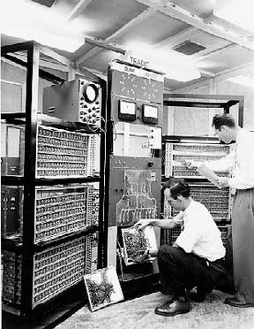

Figure 1 – First Generation Computer

ENIAC was the world first successful electronic computer which was develops by the two scientists namely J. P. Eckert and J. W. Mauchy. It was the beginning of first generation computer. The full form of ENIAC is “Electronic Numeric Integrated And Calculator” ENIAC was a very huge and big computer and its weight was 30 tones. It could store only limited or small amount of information. Initially in the first generation computer the concept of vacuum tubes was used. A vacuum tube was such an electronic component which had very less work efficiency and so it could not work properly and it required a large cooling system.



Figure 2 – First Generation Computer Z3



Figure 3 – First Generation Computer Colossus



Figure 4 – First Generation Computer Mark 1

The Harvard-IBM Automatic Sequence Controlled Calculator, made in the USA by Howard H. Aiken from Harvard University. The length was as long as half a soccer field with about 500 miles of cables. This computer is called Mark 1.

The main features of first generation are:

* Vacuum tube technology
* Unreliable
* Supported machine language only
* Very costly
* Generated lot of heat
* Slow input and output devices
* Huge size
* Need of A.C.
* Non-portable
* Consumed lot of electricity

Some computers of this generation were:

* ENIAC
* EDVAC
* UNIVAC
* IBM-701
* IBM-6509

### SECOND GENERATION

The period of second generation: 1959-1965. Transistor based.

As the development moved further, the second generation computers knocked the door. In this generation, transistors were used as the electronic component instead of vaccum tubes .A transistors is much smaller in the size than that of a vaccum tube. As the size of electrons components decreased from vaccum tube of transistor, the size of computer also decreased and it became much smaller than that of earlier computer.

The period of second generation was 1959-1965. In this generation transistors were used that were cheaper, consumed less power, more compact in size, more reliable and faster than the first generation machines made of vacuum tubes. In this generation, magnetic cores were used as primary memory and magnetic tape and magnetic disks as secondary storage devices. In this generation assembly language and high-level programming languages like FORTRAN, COBOL were used. The computers used batch processing and multiprogramming operating system.

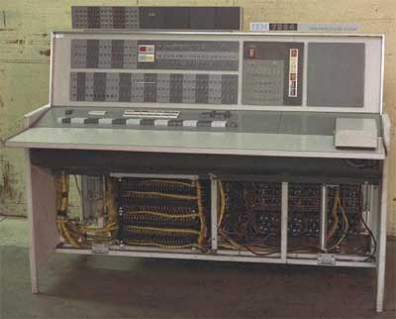

Figure 5 – Second Generation Computer

The main features of second generation are:

* Use of transistors
* Reliable in comparison to first generation computers
* Smaller size as compared to first generation computers
* Generated less heat as compared to first generation computers
* Consumed less electricity as compared to first generation computers
* Faster than first generation computers
* Still very costly
* A.C. needed
* Supported machine and assembly languages

Some computers of this generation were:

* IBM 1620
* IBM 7094
* CDC 1604
* CDC 3600
* UNIVAC 1108

### THIRD GENERATION

The period of third generation: 1965-1971. Integrated Circuit based.

The third generation computers were invented in the year 1964. In this generation of computer, IC (Integrated circuits) was used as the electronic component for computers. The development of IC gave birth to a new field of microelectronics. The main advantage of IC is not only its small size but its superior performance and reliability than the previous circuits. It was first developed by T.S Kilby. This generation of computer has huge storage capacity and higher calculating speed.

The period of third generation was 1965-1971. The computers of third generation used integrated circuits (IC's) in place of transistors. A single IC has many transistors, resistors and capacitors along with the associated circuitry. The IC was invented by Jack Kilby. This development made computers smaller in size, reliable and efficient. In this generation remote processing, time-sharing, multi-programming operating system were used. High-level languages (FORTRAN-II TO IV, COBOL, PASCAL PL/1, BASIC, ALGOL-68 etc.) were used during this generation.

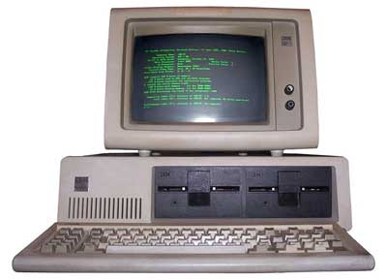

Figure 6 – Terminal of Third Generation Computer

The main features of third generation are:

* IC used
* More reliable in comparison to previous two generations
* Smaller size
* Generated less heat
* Faster
* Lesser maintenance
* Still costly
* A.C needed
* Consumed lesser electricity
* Supported high-level language

Some computers of this generation were:

* IBM-360 series
* Honeywell-6000 series
* PDP(Personal Data Processor)
* IBM-370/168
* TDC-316

### FOURTH GENERATION

The period of fourth generation: 1971-1980. VLSI microprocessor based.

The period of fourth generation was 1971-1980. The computers of fourth generation used Very Large Scale Integrated (VLSI) circuits. VLSI circuits having about 5000 transistors and other circuit elements and their associated circuits on a single chip made it possible to have microcomputers of fourth generation. Fourth generation computers became more powerful, compact, reliable, and affordable. As a result, it gave rise to personal computer (PC) revolution. In this generation time sharing, real time, networks, distributed operating system were used. All the high-level languages like C, C++, DBASE etc., were used in this generation.

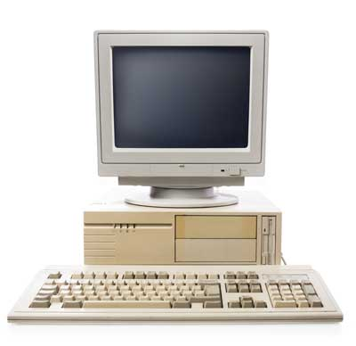

Figure 7 – PC in Forth Generation Computer

This is the generation where we are working today. The computers which we see around us belong to the fourth generation computers. ‘Micro processor’ is the main concept behind this generation of computer.

A microprocessor is a single chip (L.S.I circuit), which is used in a computer for any arithmetical or logical functions to be performed in any program. The honaur of developing microprocessor goes to Ted Hoff of U.S.A. He developed first micro-processor, the Intel 4004, as he was working for Intel Corporation, U.S.A with the use of microprocessor in the fourth generation computers, the size of computer become very fast and efficient.

It is evident that the next generation of computer i.e. fifth generation will be developed soon. In that generation, computer will possess artificial intelligence and it would be able to take self decisions like a human being.

The main features of fourth generation are:

* VLSI technology used
* Very cheap
* Portable and reliable
* Use of PC's
* Very small size
* Pipeline processing
* No A.C. needed
* Concept of internet was introduced
* Great developments in the fields of networks
* Computers became easily available

Some computers of this generation were:

* DEC 10
* STAR 1000
* PDP 11
* CRAY-1(Super Computer)
* CRAY-X-MP(Super Computer)

### FIFTH GENERATION

The period of fifth generation: 1980-onwards. ULSI microprocessor based.

The period of fifth generation is 1980-till date. In the fifth generation, the VLSI technology became ULSI (Ultra Large Scale Integration) technology, resulting in the production of microprocessor chips having ten million electronic components. This generation is based on parallel processing hardware and AI (Artificial Intelligence) software. AI is an emerging branch in computer science, which interprets means and method of making computers think like human beings. All the high-level languages like C and C++, Java, .Net etc., are used in this generation.

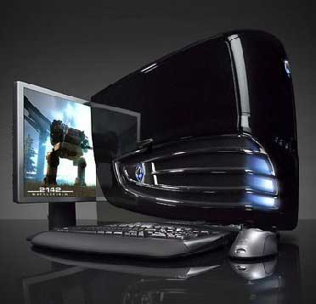

Figure 8 – Fifth Generation Computer

AI includes:

1. Robotics
2. Neural Networks
3. Game Playing
4. Development of expert systems to make decisions in real life situations.
5. Natural language understanding and generation.

The main features of fifth generation are:

1. ULSI technology
2. Development of true artificial intelligence
3. Development of Natural language processing
4. Advancement in Parallel Processing
5. Advancement in Superconductor technology
6. More user friendly interfaces with multimedia features
7. Availability of very powerful and compact computers at cheaper rates

Some computer types of this generation are:

1. Desktop
2. Laptop
3. NoteBook
4. UltraBook
5. ChromeBook

References:

<http://wikieducator.org/History_of_Computer_Development_%26_Generation_of_Computer>

<http://www.tutorialspoint.com/computer_fundamentals/computer_first_generation.htm>

<http://www.tutorialspoint.com/computer_fundamentals/computer_second_generation.htm>

<http://www.tutorialspoint.com/computer_fundamentals/computer_third_generation.htm>

<http://www.tutorialspoint.com/computer_fundamentals/computer_fourth_generation.htm>

<http://www.tutorialspoint.com/computer_fundamentals/computer_fifth_generation.htm>

# HARDWARE COMPONENTS

All types of computers follow a same basic logical structure and perform the following five basic operations for converting raw input data into information useful to their users.

|  |  |  |
| --- | --- | --- |
| **Sr.No.** | **Operation** | **Description** |
| 1 | Take Input | The process of entering data and instructions into the computer system |
| 2 | Store Data | Saving data and instructions so that they are available for processing as and when required. |
| 3 | Processing Data | Performing arithmetic, and logical operations on data in order to convert them into useful information. |
| 4 | Output Information | The process of producing useful information or results for the user, such as a printed report or visual display. |
| 5 | Control the workflow | Directs the manner and sequence in which all of the above operations are performed. |

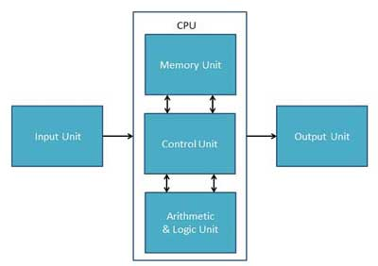

Figure 9 – Computer Basic Components

## Input Unit

This unit contains devices with the help of which we enter data into computer. This unit makes link between user and computer. The input devices translate the information into the form understandable by computer.

## CPU (Central Processing Unit)

CPU is considered as the brain of the computer. CPU performs all types of data processing operations. It stores data, intermediate results and instructions(program). It controls the operation of all parts of computer.

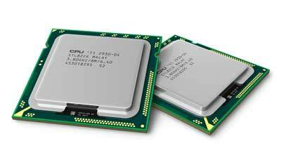

Figure 10 – CPU of the Forth Generation Computer

CPU itself has following three components

* Memory Unit

This unit can store instructions, data and intermediate results. This unit supplies information to the other units of the computer when needed. It is also known as internal storage unit or main memory or primary storage or Random access memory (RAM).

Its size affects speed, power and capability. Primary memory and secondary memory are two types of memories in the computer. Functions of memory unit are:

* It stores all the data and the instructions required for processing.
* It stores intermediate results of processing.
* It stores final results of processing before these results are released to an output device.
* All inputs and outputs are transmitted through main memory.
* Control Unit

This unit controls the operations of all parts of computer but does not carry out any actual data processing operations.

Functions of this unit are:

* It is responsible for controlling the transfer of data and instructions among other units of a computer.
* It manages and coordinates all the units of the computer.
* It obtains the instructions from the memory, interprets them, and directs the operation of the computer.
* It communicates with Input/Output devices for transfer of data or results from storage.
* It does not process or store data.
* ALU(Arithmetic Logic Unit)

This unit consists of two subsections namely:

* Arithmetic section: performs arithmetic operations like addition, subtraction, multiplication and division. All complex operations are done by making repetitive use of above operations.
* Logic Section: performs logic operations such as comparing, selecting, matching and merging of data.

## Output Unit

Output unit consists of devices with the help of which we get the information from computer. This unit is a link between computer and users. Output devices translate the computer's output into the form understandable by users.

References:

<http://www.tutorialspoint.com/computer_fundamentals/computer_components.htm>

<http://www.tutorialspoint.com/computer_fundamentals/computer_cpu.htm>

# HOW THE COMPUTER WORKS

Let us examine the way the central processing unit, in association with memory, executes a computer program. We will be looking at how just one instruction in the program is executed. In fact, most computers today can execute only one instruction at a time, though they execute it very quickly. Many personal computers can execute instructions in less than one-millionth of a second, whereas those speed demons known as supercomputers can execute instructions in less than one-billionth of a second.

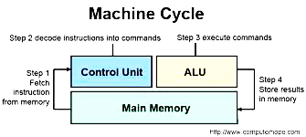

Figure 11 – The Machine Cycle

Before an instruction can be executed, program instructions and data must be placed into memory from an input device or a secondary storage device (the process is further complicated by the fact that the data will probably make a temporary stop in a register). As Figure 11 shows, once the necessary data and instruction are in memory, the central processing unit performs the following four steps for each instruction:

1. The control unit fetches (gets) the instruction from memory.
2. The control unit decodes the instruction (decides what it means) and directs that the necessary data be moved from memory to the arithmetic/logic unit. **These first two steps together are called instruction time**, or I-time.
3. The arithmetic/logic unit executes the arithmetic or logical instruction. That is, the ALU is given control and performs the actual operation on the data.
4. The arithmetic/logic unit stores the result of this operation in memory or in a register. **Steps 3 and 4 together are called execution time**, or E-time.

The control unit eventually directs memory to release the result to an output device or a secondary storage device. The combination of I-time and E-time is called the machine cycle. Figure 12 shows an instruction going through the machine cycle.

Each central processing unit has **an internal clock** that produces pulses at a fixed rate to synchronize all computer operations. A single machine-cycle instruction may be made up of a substantial number of sub-instructions, each of which must take at least one clock cycle. Each type of central processing unit is designed to understand a specific group of instructions called the instruction set. Just as there are many different languages that people understand, so each different type of CPU has an instruction set it understands. Therefore, one CPU-such as the one for a Compaq personal computer-cannot understand the instruction set from another CPU-say, for a Macintosh.

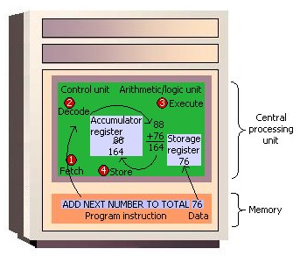

Figure 12 - The Machine Cycle in Action

It is one thing to have instructions and data somewhere in memory and quite another for the control unit to be able to find them. How does it do this?

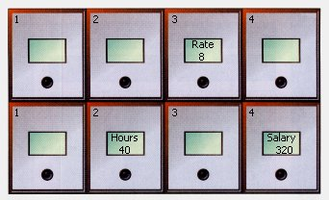

Figure 13 - Memory Addresses Like Mailboxes

The location in memory for each instruction and each piece of data is identified by an address. That is, each location has an address number, like the mailboxes in front of an apartment house. And, like the mailboxes, the address numbers of the locations remain the same, but the contents (instructions and data) of the locations may change. That is, new instructions or new data may be placed in the locations when the old contents no longer need to be stored in memory. Unlike a mailbox, however, a memory location can hold only a fixed amount of data; an address can hold only a fixed number of bytes - often two bytes in a modern computer.

Figure 13­ shows how a program manipulates data in memory. A payroll program, for example, may give instructions to put the rate of pay in location 3 row 1 and the number of hours worked in location 2 row 2. To compute the employee's salary, then, instructions tell the computer to multiply the data in location 3 row 1 by the data in location 2 row 2 and move the result to location 4 row 2. The choice of locations is arbitrary - any locations that are not already spoken for can be used. Programmers using programming languages, however, do not have to worry about the actual address numbers, because each data address is referred to by a name. The name is called a symbolic address. In this example, the symbolic address names are Rate, Hours, and Salary.

References

University of Rhode Island, the USA <http://homepage.cs.uri.edu/faculty/wolfe/book/Readings/>Reading04.htm

# HARDWARE STORAGE

Storage keeps data, information and instructions for use in the future. All computers use storage to keep the software that makes the hardware work.

As a user you store a variety of data and information on your computer or on storage media. Storage media are the physical materials on which data, information and instructions are kept. When a user saves information or data to a storage medium he or she is storing a file, and this process is called writing. When the file is opened the process is called reading.

Alternatively referred to as digital storage, storage, storage media, or storage medium, a storage device is any hardware capable of holding information either temporarily or permanently.

There are two types of storage devices used with computers:

1. Primary storage device, such as RAM,
2. Secondary storage device, like a hard drive. Secondary storage can be removable, internal, or external storage.

Without a storage device, your computer would not be able to save any settings or information and would be considered a dumb terminal.

Cache memory, also called CPU memory, is random access memory (RAM) that a computer microprocessor can access more quickly than it can access regular RAM. This memory is typically integrated directly with the CPU chip or placed on a separate chip that has a separate bus interconnect with the CPU.

The basic purpose of cache memory is to store program instructions that are frequently re-referenced by software during operation. Fast access to these instructions increases the overall speed of the software program.

As the microprocessor processes data, it looks first in the cache memory; if it finds the instructions there (from a previous reading of data), it does not have to do a more time-consuming reading of data from larger memory or other data storage devices.

Most programs use very few resources once they have been opened and operated for a time, mainly because frequently re-referenced instructions tend to be cached. This explains why measurements of system performance in computers with slower processors but larger caches tend to be faster than measurements of system performance in computers with faster processors but more limited cache space.

Multi-tier or multilevel caching has become popular in server and desktop architectures, with different levels providing greater efficiency through managed tiering. Simply put, the less frequently access is made to certain data or instructions, the lower down the cache level the data or instructions are written.

Cache memory is fast and expensive. Traditionally, it is categorized as "levels" that describe its closeness and accessibility to the microprocessor:

* **Level 1 (**L1**) cache** is extremely fast but relatively small, and is usually embedded in the processor chip (CPU).
* **Level 2 (L2) cache** is often more capacious than L1; it may be located on the CPU or on a separate chip or coprocessor with a high-speed alternative system bus interconnecting the cache to the CPU, so as not to be slowed by traffic on the main system bus.
* **Level 3 (L3) cache** is typically specialized memory that works to improve the performance of L1 and L2. It can be significantly slower than L1 or L2, but is usually double the speed of RAM. In the case of multicore processors, each core may have its own dedicated L1 and L2 cache, but share a common L3 cache. When an instruction is referenced in the L3 cache, it is typically elevated to a higher tier cache.

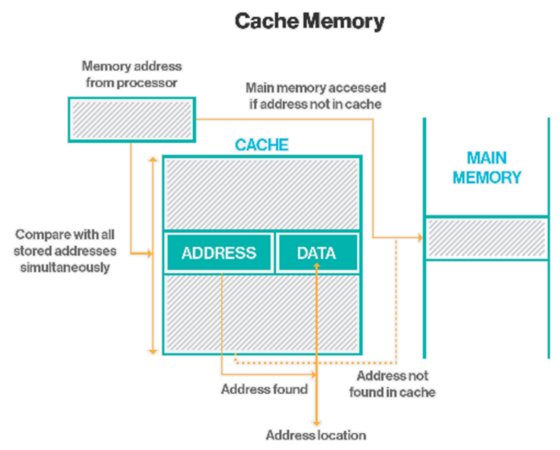

*Source: http://searchstorage.techtarget.com/definition/cache-memory*

Examples of secondary computer storage:

1. **Magnetic storage devices**

Today, magnetic storage is one of the most common types of storage used with computers and is the technology that many computer hard drives use.

|  |  |
| --- | --- |
|  | **Hard Drive**:  A hard disk drive (sometimes abbreviated as Hard drive, HD, or HDD) is a device used to permanently store and also retrieve information. This medium comes with the computer and is always inside the computer.  There are many variations, but their sizes are generally 3.5" and 2.5" for desktop and laptop computers respectively. A hard drive consists of one or more platters to which data is written using a magnetic head, all inside of an air-sealed casing. Internal hard disks reside in a drive bay, connect to the motherboard using an ATA, SCSI, or SATA cable, and are powered by a connection to the PSU (power supply unit). The image shows the components of a hard drive inside of both desktop and laptop computers.  It stores all the programs that the computer needs to work. In addition users store their data and information on the hard drive. |
|  | **Hard drive components**:  The picture shows the desktop hard drive that consists of the following components: the head actuator, read/write actuator arm, read/write head, spindle, and platter. On the back of a hard drive is a circuit board called the disk controller. |
|  | **Floppy Disk Drive**:  A Floppy Disk Drive, also called FDD or FD for short, is a computer disk drive that enables a user to save data to removable diskettes. Although 8" disk drives were first made available in 1971, the first real disk drives used were the 5 1/4" floppy disk drives, which were later replaced with the 3 1/2" floppy disk drives.  A 5 1/4"floppy disk was capable of storing between 360KB and 1.2MB of data, and the 3 1/2" floppy disk was capable of storing between 360KB and 1.44MB of data. For both sizes of floppy disk, the amount of data that could be stored was dependent on whether the disk was single or double sided and whether the disk was regular or high density.  Today, due to their extremely limited capacity, computers no longer come equipped with floppy disk drives. This technology has largely been replaced with CD-R, DVD-R, and flash drives. |
|  | **Tape**:  A magnetically thin coated piece plastic wrapped around wheels capable of storing data. Tape is much less expensive than other storage mediums but a much slower solution that was typically only used for backup.  Today, tape has mostly been abandoned for faster and more reliable solutions like disc drives, hard drives, and flash drives. In the image to the right, is a picture and example of magnetic tape taken by KENPEI and shared under the creative commons. |

1. Optical storage devices

Another common storage is optical storage, which uses lasers and lights as its method of reading and writing data.

|  |  |
| --- | --- |
|  | **Blue-ray Disk**:  Short for Blu-ray Disc, BD or BD-ROM, is an optical disc format developed by thirteen consumer electronics and PC companies. These companies include Dell, Hitachi, Hewlett Packard, LG, Mitsubishi, Panasonic, Sony, and TDK. Blu-ray was first introduced at the CES on January 4, 2006 and can store up to 25 GB single-layer disc and 50 GB on a dual-layer disc, each disc being the same size as a standard CD. The picture shows a blue laser in a Blu-ray disc player.  Today, Blu-ray was first backed by Apple, Dell, Philips, Pioneer, Sony, Sun, TDK, and other companies mentioned above. On February 19, 2008 Blu-ray beat out HD DVD in the high-definition disc format wars on after HD DVD called it quits. |
|  | **CD-ROM**:  Short for Compact Disc-Read Only Memory, a CD-ROM (shown left) is an optical disc which contains audio or software data whose memory is read only.  A CD-ROM Drive or optical drive is the device used to read them. CD-ROM drives have speeds ranging from 1x all the way up to 72x, meaning it reads the CD roughly 72 times faster than the 1x version. As you would imagine, these drives are capable playing audio CDs and reading data CDs. The picture shows the front and back of a standard CD-ROM drive. |
|  | **CD-Rand CD-RW disc:**  Alternatively referred to as a cd writer, CD-WO (Write once), WORM (Write Once Read Many) drive. CD-R is short for CD-Recordable and is a writable disc and drive that is capable of having information written to the disc once and then having that disc read many times after that. If the data is not written to the disc properly, it cannot be corrected and is often jokingly referred to as a coaster. The first recordable specification (CD-WO) was published in 1989 by Philips and Sony in the Orange Book. However, the drives were not popularized until Hewlett Packard released the HP 4020i in September 1995, which was the first sub $1,000.00 recordable disc drive.  CD-Rs are a low-cost solution for backing up software and only costs a few cents (as of 2010 around 17-cents a disc) and can hold up to 650 MB (74 minutes of music) or 700MB (80 minutes of music). Although these are still a very popular solution for backing up data, more users are turning to DVD-R and USB thumb drives to backup and transfer their data today. |
|  | **Recordable DVD drives**:  Alternatively referred to as a DVD writer, recordable DVD drives are disc drives capable of creating DVD discs. Unfortunately, unlike recordable CD drives, there are many different competing standards for creating DVD discs. For example, DVD-R, DVD-RW, DVD+R, DVD+RW, DVD+R DL (DVD+R9), and DVD-RAM are all different competing standards. Below is a brief explanation of each of these standards and related links to each of these standards.  **DVD-R**  Short for Digital Versatile Disc-Recordable, DVD-R is a drive capable of recording once to a disc and reading many times after it has been created. DVD-R is an approved standard by DVD Forum and the drives are capable of recording to DVD-R discs, also known as DVD-5 and DVD-10 discs.  **DVD-RW (DVD-R/W)**  Short for Digital Versatile Disc-Read/Write, DVD-RW is an approved standard by DVD Forum. Similar to CD-RW, it's a technology that enables a user to read and write to a DVD-RW or DVD-R disc multiple times. DVD-RW drives are capable of recording to DVD-R and DVD-RW discs and are also known as DVD-5 and DVD-10 discs.  **DVD+R SpindleDVD+R**  Short for Digital Versatile Disc-Recordable, DVD+R is DVD+RW Alliance standard of disc. DVD+R is a technology that enables a user to read and write to a DVD+RW or DVD+R disc several times. DVD+RW drives are capable of recording DVD+R discs, also known as DVD-5 and DVD-10 discs.  **DVD+RW**  Short for Digital Versatile Disc-Read/Write, DVD+R is a DVD+RW Alliance standard much like CD-RW and DVD-R. With DVD+RW you can read and write to a DVD+RW or DVD+R disc several times. DVD+RW drives are capable of recording DVD+R and DVD+RW discs, also known as DVD-5 and DVD-10 discs. |

1. Flash memory devices

Flash memory has started to replace magnetic media as it becomes cheaper as it is the more efficient and reliable solution.

|  |  |
| --- | --- |
|  | **Jump drive or flash drive**  Alternatively referred to as a USB flash drive, data stick, pen drive, memory unit, key chain drive and thumb drive, a jump drive is a portable storage device. It is often the size of a human thumb (hence the name) and it connects to a computer via a USB port. Today, flash drives are available in sizes such as 256MB, 512MB, 1GB, 5GB, and 16GB, and are an easy way to transfer and store information.  The picture to the right is one example of a flash drive. Specifically, this picture is of a SanDisk Cruzer Micro 16GB flash drive.  Unlike a standard hard drive, the flash drive has no movable parts, containing only an integrated circuit memory chip where data is stored. It usually has plastic casing surrounding the memory chip inside and has a USB connection that is plugged into the USB port on a computer. |
|  | **Memory stick**  The proprietary Sony Memory Stick was first introduced by Sony in October 1998 and is a flash memory card used with Sony digital cameras and other Sony products. Sony released several models of the Memory Stick including the Memory Stick PRO, Memory Stick Duo, Memory Stick PRO Duo, Memory Stick Micro (M2), and Memory Stick PRO-HG. The capacity of the Memory Sticks range in sizes of 4MB to 256GB, with a theoretically maximum capacity of 2TB, but they have not been produced in that capacity to date.  Today, Sony digital cameras use SD and SDHC memory cards and with no new cards being released since 2010 they will most likely be discontinued. The picture shows some examples of the different types of Sony Memory Sticks. |
|  | **Memory card**  Alternatively referred to as a flash memory card. Memory cards are a type of storage media that is most commonly used in digital cameras, digital camcorders, handheld computers, MP3 players, PDAs, cell phones, game consoles, and printers, to store pictures, videos, music, and other data. The picture is an example of a MicroSD flash memory card. This is just one of many examples of a memory card, click on any of the links below to see additional examples of other cards. |
|  | **SSD**  Short for Solid-State Drive or Solid-State Disk, SSD is a drive that uses non-volatile memory as a means of storing and accessing data, much like computer RAM. Unlike a hard drives, an SSD has no moving parts, which gives it advantages such as accessing stored information faster, no noise, often more reliable, and consume less power. The picture shows a Crucial SSD and is an example of an SSD.  The first SSD was implemented in IBM supercomputers in the 1970s and 1980s. They have since been drastically improved upon and offer storage capacities of 128GB and 256GB for home computers. Unfortunately, because of the much greater cost per GB of storing information these drives have not yet become suitable solutions for replacing a standard computer's hard drive. However, are a great solution for netbooks, nettops, and other applications that don't require several hundred GB of space. |

1. Online and cloud

Storing data online and in cloud storage is becoming popular as people need to access their data from more than one device.

|  |  |
| --- | --- |
|  | **Cloud storage**  Cloud computing is a term used to describe services provided over a network by a collection of remote servers. This abstract "cloud" of computers provides massive, distributed storage and processing power, which can be accessed by any Internet-connected device running a web browser.  Because the term cloud computing is a broad term, it is likely if you have spent any time on the Internet or use devices connected to the Internet that you have used some cloud computing. |
|  | **Network media**  Network media is any audio, video, images or text, used on a computer network, like the Internet. It almost always requires a computer to send and receive, as well as a community of people to create and consume the content.  Network media are decentralized and contributed by many people, who not only provide it to others, but are also recipients and users of the media. |

**Paper storage**

Early computers had no method of using any of the above technologies for storing information and had to rely on paper. Today, these forms of storage are rarely used or found.

|  |  |
| --- | --- |
|  | **OMR**  Short for Optical Mark Reading or Optical Mark Recognition, OMR is the process of gathering information from human beings by recognizing marks on a document. OMR is accomplished by using a hardware device (scanner) that detects a reflection or limited light transmittance on or through piece of paper.  OMR allows for the processing of hundreds or thousands of physical documents per hour. For example, students may recall taking tests or surveys where they filled in bubbles on paper (shown right) with pencil. Once the form had been completed, a teacher or teacher's assistant would feed the cards into a system that grades or gathers information from them. |
|  | **Punch card**  Early method of data storage used with early computers. Punch cards also known as Hollerith cards and IBM cards are paper cards containing several punched holes that were punched by hand or machine to represent data. These cards allowed companies to store and access information by entering the card into the computer. The picture is an example of a punch card.  Punch cards are known to be used as early as 1725 for controlling textile looms. The cards were later used to store and search for information in 1832 by Semen Korsakov. Later in 1890, Herman Hollerith developed a method for machines to record and store information on punch cards to be used for the US census. He later formed the company we know as IBM.  Punch cards were the primary method of storing and retrieving data in the early 1900s, and began being replaced by other methods in the 1960s and today are rarely used. |

When saving anything on a computer, it may ask you for a storage location, which is the area in which you would like to save the information. By default, most information is saved to your computer hard drive. If you want to move the information to another computer, save it to a removable storage device such as a flash drive.

References:

A. Idria, A.N. Raihan, A.A. Hidayat, Type Of Storage Media, ICS Assignment, Universitas Al Azhar Indonesia, October 2015

<http://www.computerhope.com/jargon/s/stordevi.htm>

Boston University <http://people.bu.edu/baws/storage%20media.html>

# HARDWARE INPUT/OUTPUT

**Input Hardware** consists of devices that translate data into a form the computer can process. The people-readable form of the data may be words, but the computer-readable form consists of binary 0s and 1s, or off and on electrical signals.

**Output Hardware** consists of devices that translate information processed by the computer into a form that humans can understand. Such output may be in the form of words, numbers, sounds, and pictures.

## Input Hardware

Input Hardware may be divided into three categories:

1. **Keyboards**

Keyboards are devices that convert characters into electrical signals readable by the processor. There are two categories of keyboards:

1. The **traditional computer keyboard**, which has all the keys of a typewriter plus some that are unique.
2. **Specialty keyboards and terminals**, includes three types of terminals:

|  |  |
| --- | --- |
|  | (1) A dumb terminal has a screen and a keyboard and can input and output but not process data. |
|  | (2) An intelligent terminal has a screen, a keyboard, and its own processor and memory. One example is the automated teller machine (ATM), the self-service banking machine. Another is the point-of-sale (POS) terminal, used to record purchases in a store. |
|  | (3) An internet terminal provides access to the internet. Examples are set-top boxes or Web terminals, stripped-down network computers, online game players, PC/TVs, and handheld wireless pocket PCs or personal digital assistants (PDAs). |

1. **Pointing devices**

Pointing devices control the cursor or pointer on a screen and allow the user to select options displayed on the screen. They include the mouse and its variants, the touch screen, and various forms of pen input.

1. The **mouse**, which directs a pointer on the display screen, maneuvers a ball with the help of the surface on which the mouse is slid. Variants are the trackball, a movable ball mounted on a stationary device; the pointing stick, which protrudes from the keyboard; and the touchpad, a surface over which you move your finger.
2. The **touch screen** is a display screen that is sensitive to touch.
3. Devices for **pen input** include pen-based computer systems, in which users write with a pen-like stylus on a screen; light pens, light-sensitive pen-like devices; and digitizers, which convert drawings to digital data – one example is the digitizing tablet.
4. **Source-data entry devices**.

Source-data entry devices create machine-readable data on magnetic media or paper, or feed it directly into the computer's processor.

These include various scanning devices like bar-code readers, mark- and character-recognition devices, and fax machines; audio and video input devices (digital cameras); sensors; radio-frequency identification devices; and human-biology input devices.

1. **Scanners** use laser beams and reflected light to translate images of text, drawings, and photographs into digital form. One of the most famous types of scanners is the flatbed scanner that works like a photocopier. Scanning technology has ushered in the new industry of electronic imaging. Another scanning device is the bar code reader, which reads the zebra-striped barcodes on products to translate them into digital code. Magnetic-ink character recognition (MICR) reads check numbers; optical mark recognition (OMR) reads pencil marks; optical character recognition (OCR) reads preprinted characters, such as those on store price tags. The fax machine, the last type of scanner, reads images and sends them over phone lines. Dedicated fax machines only send and receive fax documents; fax modems are modems with fax capabilities.

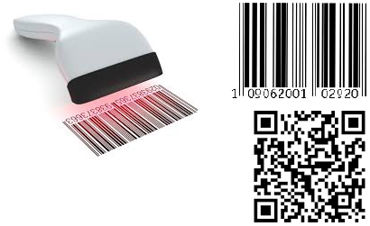

Figure 14 – scanner to read barcodes or QR codes

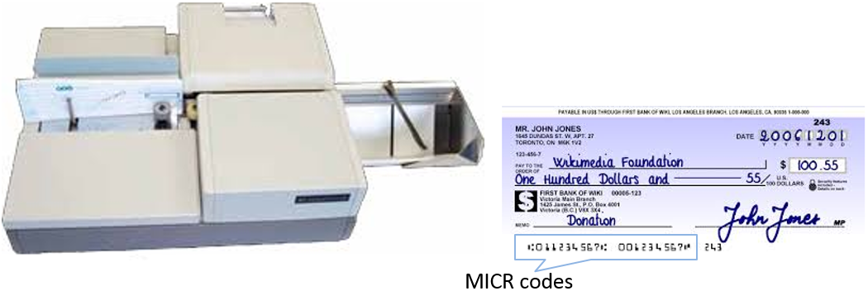

Figure 15 – MICR Code Reader to re MICR Codes on checks

1. **Audio-input devices** translate analog sounds (those with continuously variable waves) into digital 0s and 1s, either through audio boards or MIDI boards.
2. **Video-input cards** translate analog film and videotape signals into digital form, using either frame-grabber video cards or full-motion video cards.
3. **Digital cameras** use light-sensitive processor chips to capture photographic images in digital form.
4. **Speech-recognition systems** process signals by comparing electrical patterns produced by voices, with prerecorded patterns stored in a computer.
5. **Sensors** collect data directly from the environment and transmit it to a computer.
6. **Radio-frequency identification** (or RF-ID tagging) is based on an identifying tag bearing microchip that contains code numbers; these numbers are read by radio waves of a scanner linked to a database.
7. **Human-biology input devices** include biometric systems, which use biometrics, the study of body characteristics, to identify people.

## Output Hardware.

Output hardware converts machine-readable information into people-readable form. Three common types of outputs are softcopy, hardcopy, and other.

1. **Softcopy** refers to printed data that is not printed, such as that shown on a display screen. A display screen (monitor, screen) shows programming instructions and data as they are being input and information after it is processed. Screen clarity is affected by dot pitch, or space between pixels (the small units on screen that can be turned on or off); by resolution, which involves the number of pixels per square inch; color depth, which is the amount of information expressed in bits, that is stored in a dot; and by refresh rate, the number of times per second pixels are recharged.

Two common types of monitors are CRT and flat-panel:

|  |  |
| --- | --- |
|  | A CRT (cathode-ray tube) is a vacuum tube. |
|  | A flat-panel display consists of two plates of glass separated by a layer of a substance in which light is manipulated; one technology is liquid crystal display (LCD), in which molecules of liquid crystals create images by transmitting or blocking light.  Flat-panel screens are either active-matrix display, in which a unique transistor controls each pixel on the screen, or passive-matrix display, in which a transistor controls a row or a column of pixels.  The common color and resolution standards for monitors are SVGA (the most common), which can produce 16 million possible colors, XGA, which can produce 65,536 possible colors, SXGA which is used by graphic designers and programmers, UXGA which can support up to 16.8 million colors, and QXGA which is used for large LCD screens for computer users needing to view extreme details. |

1. **Hardcopy**refers to a printed output. A printer prints characters or images on paper or some other medium. Resolution of the image is measured by dpi (dots per inch), with more dots producing greater sharpness.

The two types of printers are:

1. Impact printers– form images by striking a print hammer or wheel against an inked ribbon, leaving an image on paper; one type is the dot-matrix printers, which contains a print head of small pins.
2. Nonimpact printers – form characters or images without direct physical contact between printing mechanism and paper.

There are three types of nonimpact printers commonly used:

* + **Laser**– creates images with dots like a photocopying machine; the printer uses a page description language, software that describes the images to the printer.
  + **Ink-jet**– sprays electrically charged droplets of ink at high speed onto paper.
  + **Thermal**– uses colored waxes and heat to burn dots onto special paper.

A special kind of printer, the **plotter**, which may be ink-jet or electrostatic, produces high-quality graphics, such as maps, that are too large for regular printers. Another category of printer is the **multifunction printer**, which combines printing, scanning, copying, and faxing in one device.

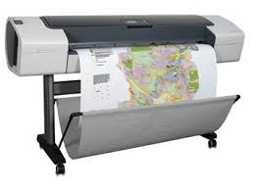

Figure 16 - Plotter

1. **Other Output**: Other forms of output are sound, voice, and video. Sound-output devices produce digitized sound. Voice-output devices convert digital data into speech-like sounds. Video consists of photographic images, played at 15-29 frames per second; in one form of video output called videoconferencing people have online meetings using computers and communications devices that enable them to see and hear one another.

## The Future of Input & Output.

Increasingly, input will be performed in remote locations and will rely on source data automation. Future source data automation will include high-capacity bar codes, 3-D scanners, more sophisticated touch devices, smarter smart cards, more diverse sensors, better voice recognition, smaller electronic cameras, more sophisticated biometric devices, and even brainwave input devices.

Output, too, is being performed in remote locations. On the horizon are better, cheaper, and larger display screens; higher-fidelity audio using wavetable synthesis and three-dimensional sound; and "real-time" video using digital wavelet theory. Thanks to 3-D technology, three-dimensional images can appear on computer displays and, through VRML software, users of the World Wide Web can experience 3-D "virtual worlds."

## Input & Output Technology &Quality of Life.

Health & Ergonomics. The use of computers and communications technology can have important effects on our health. Some of these are repetitive stress (strain) injuries (RSIs) such as carpal tunnel syndrome; computer vision syndrome, such as eyestrain and headaches; and back and neck pains. Some people are concerned about electromagnetic fields (EMFs), waves of electrical and magnetic energy emitted from CRTs, cellphones, and the like.

Negative health effects have increased interest in the field of ergonomics, the study of the relationship of people to a work environment.

Reference:

D. Septian, D. Aji, B. Faturrahman, Hardware Input/Ouput, ICS Assignment, Universitas Al Azhar Indonesia, October 2015

<http://highered.mheducation.com/sites/007288293x/student_view0/chapter6/index.html>

# TYPE OF COMPUTER HARDWARE

## Computer sizes and power

Computers can be generally classified by size and power as follows, though there is considerable overlap:

* Personal computer: A small, single-user computer based on a microprocessor.
* Workstation: A powerful, single-user computer. A workstation is like a personal computer, but it has a more powerful microprocessor and, in general, a higher-quality monitor.
* Minicomputer: A multi-user computer capable of supporting up to hundreds of users simultaneously.
* Mainframe: A powerful multi-user computer capable of supporting many hundreds or thousands of users simultaneously.
* Supercomputer: An extremely fast computer that can perform hundreds of millions of instructions per second.

### Supercomputer and Mainframe

Supercomputer is a broad term for one of the fastest computers currently available. Supercomputers are very expensive and are employed for specialized applications that require immense amounts of mathematical calculations (number crunching). For example, weather forecasting requires a supercomputer. Other uses of supercomputers scientific simulations, (animated) graphics, fluid dynamic calculations, nuclear energy research, electronic design, and analysis of geological data (e.g. in petrochemical prospecting). Perhaps the best known supercomputer manufacturer is Cray Research.

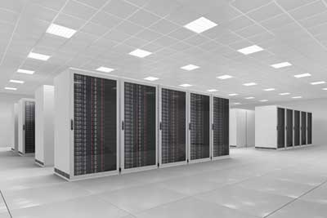

Figure 17 - Supercomputer

Mainframe was a term originally referring to the cabinet containing the central processor unit or "main frame" of a room-filling Stone Age batch machine. After the emergence of smaller "minicomputer" designs in the early 1970s, the traditional big iron machines were described as "mainframe computers" and eventually just as mainframes. Nowadays a Mainframe is a very large and expensive computer capable of supporting hundreds, or even thousands, of users simultaneously. The chief difference between a supercomputer and a mainframe is that a supercomputer channels all its power into executing a few programs as fast as possible, whereas a mainframe uses its power to execute many programs concurrently. In some ways, mainframes are more powerful than supercomputers because they support more simultaneous programs. But supercomputers can execute a single program faster than a mainframe. The distinction between small mainframes and minicomputers is vague, depending really on how the manufacturer wants to market its machines.

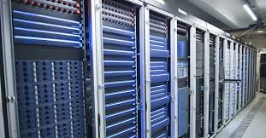

Figure 18 - Mainframe Computer

### Minicomputer

It is a midsize computer. In the past decade, the distinction between large minicomputers and small mainframes has blurred, however, as has the distinction between small minicomputers and workstations. But in general, a minicomputer is a multiprocessing system capable of supporting from up to 200 users simultaneously.

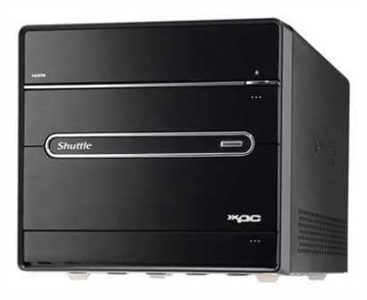

Figure 19 - Minicomputer

### Workstation

It is a type of computer used for engineering applications (CAD/CAM), desktop publishing, software development, and other types of applications that require a moderate amount of computing power and relatively high quality graphics capabilities. Workstations generally come with a large, high-resolution graphics screen, at large amount of RAM, built-in network support, and a graphical user interface. Most workstations also have a mass storage device such as a disk drive, but a special type of workstation, called a diskless workstation, comes without a disk drive. The most common operating systems for workstations are UNIX and Windows NT. Like personal computers, most workstations are single-user computers. However, workstations are typically linked together to form a local-area network, although they can also be used as stand-alone systems.

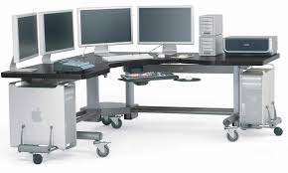

Figure 20 - Workstations

### Personal computer:

It can be defined as a small, relatively inexpensive computer designed for an individual user. In price, personal computers range anywhere from a few hundred pounds to over five thousand pounds. All are based on the microprocessor technology that enables manufacturers to put an entire CPU on one chip. Businesses use personal computers for word processing, accounting, desktop publishing, and for running spreadsheet and database management applications. At home, the most popular use for personal computers is for playing games and recently for surfing the Internet.

Personal computers first appeared in the late 1970s. One of the first and most popular personal computers was the Apple II, introduced in 1977 by Apple Computer. During the late 1970s and early 1980s, new models and competing operating systems seemed to appear daily. Then, in 1981, IBM entered the fray with its first personal computer, known as the IBM PC. The IBM PC quickly became the personal computer of choice, and most other personal computer manufacturers fell by the wayside. P.C. is short for personal computer or IBM PC. One of the few companies to survive IBM's onslaught was Apple Computer, which remains a major player in the personal computer marketplace. Other companies adjusted to IBM's dominance by building IBM clones, computers that were internally almost the same as the IBM PC, but that cost less. Because IBM clones used the same microprocessors as IBM PCs, they were capable of running the same software. Over the years, IBM has lost much of its influence in directing the evolution of PCs. Therefore after the release of the first PC by IBM the term PC increasingly came to mean IBM or IBM-compatible personal computers, to the exclusion of other types of personal computers, such as Macintoshes. In recent years, the term PC has become more and more difficult to pin down. In general, though, it applies to any personal computer based on an Intel microprocessor, or on an Intel-compatible microprocessor. For nearly every other component, including the operating system, there are several options, all of which fall under the rubric of PC.

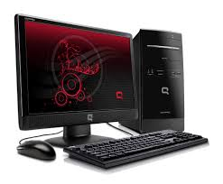

Figure 21 - Personal Computer

Today, the world of personal computers is basically divided between Apple Macintoshes and PCs. The principal characteristics of personal computers are that they are single-user systems and are based on microprocessors. However, although personal computers are designed as single-user systems, it is common to link them together to form a network. In terms of power, there is great variety. At the high end, the distinction between personal computers and workstations has faded. High-end models of the Macintosh and PC offer the same computing power and graphics capability as low-end workstations by Sun Microsystems, Hewlett-Packard, and DEC.

## Personal Computer Types

Actual personal computers can be generally classified by size and chassis/case. The chassis or case is the metal frame that serves as the structural support for electronic components. Every computer system requires at least one chassis to house the circuit boards and wiring. The chassis also contains slots for expansion boards. If you want to insert more boards than there are slots, you will need an expansion chassis, which provides additional slots. There are two basic flavors of chassis designs–desktop models and tower models–but there are many variations on these two basic types. Then come the portable computers that are computers small enough to carry. Portable computers include notebook and subnotebook computers, hand-held computers, palmtops, and PDAs.

* Tower model

The term refers to a computer in which the power supply, motherboard, and mass storage devices are stacked on top of each other in a cabinet. This is in contrast to desktop models, in which these components are housed in a more compact box. The main advantage of tower models is that there are fewer space constraints, which makes installation of additional storage devices easier.

* Desktop model

A computer designed to fit comfortably on top of a desk, typically with the monitor sitting on top of the computer. Desktop model computers are broad and low, whereas tower model computers are narrow and tall. Because of their shape, desktop model computers are generally limited to three internal mass storage devices. Desktop models designed to be very small are sometimes referred to as slimline models.

* Notebook computer

An extremely lightweight personal computer. Notebook computers typically weigh less than 6 pounds and are small enough to fit easily in a briefcase. Aside from size, the principal difference between a notebook computer and a personal computer is the display screen. Notebook computers use a variety of techniques, known as flat-panel technologies, to produce a lightweight and non-bulky display screen. The quality of notebook display screens varies considerably. In terms of computing power, modern notebook computers are nearly equivalent to personal computers. They have the same CPUs, memory capacity, and disk drives. However, all this power in a small package is expensive. Notebook computers cost about twice as much as equivalent regular-sized computers. Notebook computers come with battery packs that enable you to run them without plugging them in. However, the batteries need to be recharged every few hours.

* Laptop computer

A small, portable computer -- small enough that it can sit on your lap. Nowadays, laptop computers are more frequently called notebook computers.

* Subnotebook computer

A portable computer that is slightly lighter and smaller than a full-sized notebook computer. Typically, subnotebook computers have a smaller keyboard and screen, but are otherwise equivalent to notebook computers.

* Hand-held computer

A portable computer that is small enough to be held in one’s hand. Although extremely convenient to carry, handheld computers have not replaced notebook computers because of their small keyboards and screens. The most popular hand-held computers are those that are specifically designed to provide PIM (personal information manager) functions, such as a calendar and address book. Some manufacturers are trying to solve the small keyboard problem by replacing the keyboard with an electronic pen. However, these pen-based devices rely on handwriting recognition technologies, which are still in their infancy. Hand-held computers are also called PDAs, palmtops and pocket computers.

* Palmtop

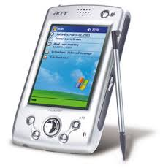A small computer that literally fits in your palm. Compared to full-size computers, palmtops are severely limited, but they are practical for certain functions such as phone books and calendars. Palmtops that use a pen rather than a keyboard for input are often called hand-held computers or PDAs. Because of their small size, most palmtop computers do not include disk drives. However, many contain PCMCIA slots in which you can insert disk drives, modems, memory, and other devices. Palmtops are also called PDAs, hand-held computers and pocket computers.

* PDA

Figure 22 - Personal Digital Assistance

Short for personal digital assistant, a handheld device that combines computing, telephone/fax, and networking features. A typical PDA can function as a cellular phone, fax sender, and personal organizer. Unlike portable computers, most PDAs are pen-based, using a stylus rather than a keyboard for input. This means that they also incorporate handwriting recognition features. Some PDAs can also react to voice input by using voice recognition technologies. The field of PDA was pioneered by Apple Computer, which introduced the Newton MessagePad in 1993. Shortly thereafter, several other manufacturers offered similar products. To date, PDAs have had only modest success in the marketplace, due to their high price tags and limited applications. However, many experts believe that PDAs will eventually become common gadgets.

PDAs are also called palmtops, hand-held computers and pocket computers.

References:

Carnegie Mellon University, School of Computer Science, Pittsburgh, Pennsylvania, USA, https://www.cs.cmu.edu/~fgandon/lecture/uk1999/computers_types/

<http://www.tutorialspoint.com/computer_fundamentals/computer_types.htm>

# DEFINITIONS OF SOFTWARE

Software can be thought of as the variable part of a computer and hardware the invariable part. Software is often divided into application software (programs that do work users are directly interested in) and system software (which includes operating systems and any program that supports application software). The term middleware is sometimes used to describe programming that mediates between application and system software or between two different kinds of application software (for example, sending a remote work request from an application in a computer that has one kind of operating system to an application in a computer with a different operating system).

**Software:** is a sequences of instructions for the computer to execute its tasks.



## Starting-up the computer

When you start-up your computer from a powered-down state (cold boot) or when you reset it because a program encounters an error from which it cannot recover (warm boot, e.g.: [Control]+[Alt]+[Delete]) your computer is going to carry out a series of initializations, tests and loading called boot. Boot is short for bootstrap, which in olden days was a strap attached to the top of your boot that you could pull to help get your boot on. Hence, the expression “pull oneself up by the bootstraps.” Similarly, bootstrap utilities help the computer get started.

The BIOS (Basic Input Output System) is responsible for booting the computer by providing a basic set of instructions and gives the computer a little built-in starter kit to run the rest of software from floppy disks (FDD) and hard disks (HDD). The BIOS performs all the tasks that need to be done at start-up time: POST. POST is a short for power-on self test, a series of diagnostic tests that run automatically when you turn your computer on. The actual tests can differ depending on how the BIOS is configured, but usually the POST tests the RAM, the keyboard, and the disk drives. If the tests are successful, the computer boots itself. If the tests are unsuccessful, the computer reports the error by emitting a series of beeps and possibly displaying an error message and code on the display screen. The number of beeps indicates the error, but differs from one BIOS to another. If the test is positive the BIOS proceeds to boot an operating system from FDD or HDD).

Furthermore, the BIOS provides an interface to the underlying hardware for the operating system in the form of a library of interrupt handlers, that all the code required to control the keyboard, display screen, disk drives, serial communications, and a number of miscellaneous functions. For instance, each time a key is pressed, the CPU (Central Processing Unit) perform an interrupt to read that key. This is similar for other input/output devices (Serial and parallel ports, video cards, sound cards, hard disk controllers, etc...). Some older PC's cannot co-operate with all the modern hardware because their BIOS does not support that hardware. The operating system cannot call a BIOS routine to use it; this problem can be solved by replacing your BIOS with a newer one, that does support your new hardware, or by installing a device driver for the hardware.

The BIOS is typically placed in a ROM (Read Only Memory) chip that comes with the computer (it is often called a ROM BIOS). This ensures that the BIOS will always be available and will not be damaged by disk failures for example. Because RAM is faster than ROM many computer manufacturers design systems so that the BIOS is copied from ROM to RAM each time the computer is booted. This is known as shadowing. Many modern PCs have a flash BIOS, which means that the BIOS has been recorded on a flash memory chip, which can be updated if necessary.

To perform its tasks, the BIOS need to know various parameters (hardware configuration). These are permanently saved in a little piece (64 bytes) of CMOS RAM (Complementary Metal Oxide Semiconductor Random Access Memory). The CMOS power is supplied by a little battery, so its contents will not be lost after the PC is turned off. Therefore, there is a battery and a small RAM memory on board, which never (should...) loses its information. The memory was in earlier times a part of the clock chip, now it's part of such a highly Integrated Circuit (IC). CMOS is the name of a technology that needs very low power so the computer's battery is not too much in use. Actually, there is not a battery on new boards, but an accumulator (Ni_Cad in most cases). It is recharged every time the computer is turned on. If your CMOS is powered by external batteries, be sure that they are in good operating condition. Also, be sure that they do not leak. That may damage the motherboard. Otherwise, your CMOS may suddenly "forget" its configuration and you may be looking for a problem elsewhere. Some new motherboards have a technology named the Dallas Nov-Ram. It eliminates having an on-board battery: There is a 10 year lithium cell epoxyed into the chip.

To change the parameters with which the BIOS configures your chipset (integrated circuits containing the core functionality of the motherboard and extension board) you will use a set of procedures named the SETUP. The original IBM PC was configured by means of DIP switches (Dual-In-line Package) buried on the motherboard. Setting PC and XT DIP switches properly was something of an arcane art. DIP (Dual-In-line Package) switches/jumpers are still used for memory configuration and clock speed selection. When the PC-AT was introduced, it included the battery powered CMOS memory. CMOS was originally set by a program on the Diagnostic Disk, however later clones incorporated routines in the BIOS which allowed the CMOS to be (re)configured if certain magic keystrokes were used (e.g. [DEL]). Unfortunately as the chipsets controlling modern CPUs have become more complex, the variety of parameters specifiable in SETUP has grown. Moreover, there has been little standardization of terminology between the half dozen BIOS vendors, three dozen chipset makers and large number of motherboard vendors. Complaints about poor motherboard documentation of SETUP parameters are very common. To exacerbate matters, some parameters are defined by BIOS vendors, others by chipset designers, others by motherboard designers, and others by various combinations of the above. Parameters intended for use in Design and Development, are intermixed with parameters intended to be adjusted by technicians

PC BIOS that can handle Plug-and-Play (PnP) devices are known as PnP BIOS, or PnP-aware BIOS. Plug-and-play refers to the ability of a computer system to automatically configure expansion boards and other devices. You should be able to plug in a device and play with it, without worrying about setting DIP switches, jumpers, and other configuration elements. The PnP BIOS are always implemented with flash memory rather than ROM. ESCD is a short for Extended System Configuration Data, a format for storing information about Plug-and-Play (PnP) devices in the BIOS. Windows and the BIOS access the ESCD area each time you re-boot your computer. SCAM is a short for SCSI Configuration Automatically, a subset of the PnP specification that provides plug-and-play support for SCSI devices.

To conclude this part we can notice that the BIOS is always the first software to be executed by a computer.

## Software types

Software is computer instructions or data. Anything that can be stored electronically is software. The distinction between software and hardware is sometimes confusing because they are so integrally linked. Clearly, when you purchase a program, you are buying software. But to buy the software, you need to buy the disk (hardware) on which the software is recorded. Without software, a computer is just a black box of electronic equipment that is incapable of any useful function. Software tells the computer what to do and when to do it.

First there is a fundamental difference between programs and data:

* Distinct pieces of information, usually formatted in a special way and available for, or result of, processing.
* Programs are collections of instructions for processing data

Software is often divided into two categories:

* System software: Consists of low-level programs that interact with the computer at a very basic level. It is any software required to support the development or execution control of application programs but which is not specific to any particular application. This includes operating systems, compilers, loaders, linkers, debuggers and utilities for managing computer resources.
* Application software: Sits on top of systems software because it is unable to run without the operating system and system utilities. It includes programs that do real work for users. For example, word processors, spreadsheets, and database management systems fall under the category of general-purpose applications software. Whereas contract evaluation, stock control, payroll fall under the category of specific-purpose applications software

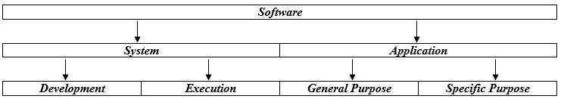

The term 'Software' has some derivatives:

**Firmware**: Software (programs or data) that has been written onto read-only memory (ROM). Firmware is a combination of software and hardware. ROMs, PROMs and EPROMs that have data or programs recorded on them are firmware. So we can sum up what have been said since the beginning of this document with the following figure:

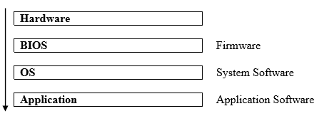

Public-domain software: Refers to any program that is not copyrighted. Public-domain software is free and can be used without restrictions.

**Freeware**: Copyrighted software given away for free by the author. Although it is available for free, the author retains the copyright, which means that you cannot do anything with it that is not expressly allowed by the author. Usually, the author allows people to use the software, but not sell it.

**Shareware**: Software distributed on the basis of an honor system. Most shareware is delivered free of charge, but the author usually requests that you pay a small fee if you like the program and use it regularly. By sending the small fee, you become registered with the producer so that you can receive service assistance and updates. The free use of the software is also usually limited to a period, in general '30 days trial period'. You can copy shareware and pass it along to friends and colleagues, but they too are expected to pay a fee if they use the product. Shareware is inexpensive because it is usually produced by a single programmer and is offered directly to customers. Thus, there are practically no packaging or advertising expenses. Note that shareware differs from public-domain software in that shareware is copyrighted. This means that you cannot sell a shareware product as your own.

You may also encounter the term Demoware that usually refers to a cut-down shareware version of a commercial product enabling the user to get the taste of the application without the access to all functionality.

The major par of the software is commercial, and this implies a five other types of license agreement:

* **Single License**: A single copy is bought and is supplied with the installation disks and the manuals. The software can only be installed on a single machine. Each extra machine is added by purchasing another complete package.
* **Site License**: A single copy of the software is bought with the permission to install the software on an agreed number of computers and only a few copies of the manuals are provided. This is a cheaper method than purchasing a single copy for each machine. An increase in the number of licensed users is achieved by paying for an extension to the existing licensed amount.
* **License by Use**: This allows the software to be installed on a large number of computers, but the license only allows a fixed number of users to be operating the software at any one time. Increasing the users on this system is identical to the site license arrangements
* **License by Station**: This allows a fixed number of machines to have the software installed. If it is a single-user license, the software must reside on a single machine.
* **Network Multi-License**: If an organization has a local area network, an individual software package for all the computers will reside as a single copy on a server. Many single-user packages will refuse to work over a network and special network versions have to be bought. Only a fixed number of users will be able to access the package on the server at any one time.

## Software creation and programming languages

The 'raison d'être' of a piece of software is always a 'problem' that needs to be solved. The first step is then to develop an algorithm, that is to say a formula or set of steps for solving a particular problem. To be an algorithm, a set of rules must be unambiguous and have a clear stopping point. Algorithms can be expressed in any language, from natural languages like English or French to drawings, chart, and even programming languages. We use algorithms every day. For example, a recipe for baking a cake is an algorithm. Most programs, with the exception of some artificial intelligence applications, consist of algorithms. Inventing elegant algorithms -- algorithms that are simple and require the fewest steps possible -- is one of the principal challenges in programming.

Once you designed an algorithm to solve your problem, you have to code it in a programming language. This stage is sometime called 'implementation' and the result is program. The noun "program" describes a single, complete and more-or-less self-contained list of instructions, often stored in a single file, whereas "code" is uncountable noun describing some number of instructions which may constitute one or more programs or part thereof. To continue the parallel with a cooking recipe we can say that the program contains a list of ingredients (called variables) and a list of directions (called statements) that tell the computer what to do with the variables. The variables can represent numeric data, text, or graphical images.

When you buy software, you normally buy an executable version of a program. This means that the program is already in machine language -- it has already been compiled and assembled and is ready to execute. Therefore most programs rely heavily on various kinds of operating system software for their execution.

To code your algorithm you can choose low-level languages (closer to the language used by a computer) or high-level languages (closer to human languages), but eventually every program must be translated into a machine language that the computer can understand:

* The assembly code (low-level) must go through an assembler that translates it to machine language.
* The high-level language code must be compiled or interpreted

So there are two ways to run programs written in a high-level language. The most common is to compile the program; the other method is to pass the program through an interpreter.

To compile is to transform a program written in a high-level programming language from source code into object code. Programmers write programs in a form called source code. Source code must go through several steps before it becomes an executable program. The first step is to pass the source code through a compiler, which translates the high-level language instructions into object code which is often the same as or similar to a computer's machine language. The final step in producing an executable program is to pass the object code through a linker (or assemblers, binders, loaders). The linker combines modules and gives real values to all symbolic addresses, thereby producing machine code.

The compiler derives its name from the way it works, looking at the entire piece of source code and collecting and reorganizing the instructions. Thus, a compiler differs from an interpreter, which analyzes and executes each line of source code in succession, without looking at the entire program. An interpreter is a program that directly interprets and executes instructions written in a high-level language.

The advantage of a compiler is that once the program is compiled it does not need any other program (except the OS) to run. Moreover, programs produced by compilers run much faster than the same programs executed by an interpreter. Every high-level programming language (except strictly interpretive languages) comes with a compiler. Because compilers translate source code into object code, which is unique for each type of computer, many compilers are available for the same language. For example, there is a C++ compiler for PCs and another for Apple Macintosh computers. In addition, the compiler industry is quite competitive, so there are actually many compilers for each language on each type of computer. More than a dozen companies develop and sell C compilers for the PC.

The advantage of interpreters is that they can execute a program immediately. Compilers require some time before an executable program emerges, and the process can be time-consuming if the program is long. For this reason, interpreters are sometimes used during the development of a program, when a programmer wants to add small sections at a time and test them quickly. In addition, interpreters are often used in education because they allow students to program interactively. Both interpreters and compilers are available for most high-level languages. However, BASIC and LISP are especially designed to be executed by an interpreter. In addition, page description languages, such as PostScript, use an interpreter. Every PostScript printer, for example, has a built-in interpreter that executes PostScript instructions.

Assembler, compiler, interpreter and linker are system software.

In the history of computing we generally distinguish several generations of languages:

* First generation language (1GL): The machine codes

The machine code is the (binary) representation of a computer program that is actually read and interpreted by the computer. When computers were first "programmed" from an input device, rather than by being rewired, they were fed input in the form of numbers, which they then interpreted as commands. A program in machine code consists of a sequence of machine instructions (possibly interspersed with data). Instructions are binary strings which may be either all the same size (e.g. one 32-bit word for many modern RISC microprocessors) or of different sizes, in which case the size of the instruction is determined from the first word (e.g. Motorola 68000) or byte (e.g. Inmos transputer). A program fragment might look like "010101 010110". The collection of all possible instructions for a particular computer is known as its "instruction set". Execution of machine code may either be hard-wired into the central processing unit or it may be controlled by microcode. The basic execution cycle consists of fetching the next instruction from main memory, decoding it (determining which operation it specifies and the location of any arguments), executing it by opening various gates (e.g. to allow data to flow from main memory into a CPU register) and enabling functional units (e.g. signalling to the ALU -arithmetic logic unit of the CPU- to perform an addition). Almost no one programs in machine language anymore.

* Second generation language (2GL): The Assembly languages

Assembly languages have the same structure and set of commands as machine languages, but they enable a programmer to use names instead of numbers. Each type of CPU has its own machine language and assembly language, so an assembly language program written for one type of CPU won’t run on another. In the early days of programming, all programs were written in assembly language. Now, most programs are written in a high-level. Programming in assembly language is slow and error-prone but is the only way to squeeze every last bit of performance out of the hardware and therefore programmers still use assembly language when speed is essential or when they need to perform an operation that isn't possible in a high-level language. An assembler is a program that translates programs from assembly language to machine language.

* Third generation language (3GL): The High level languages

A high-level language is designed to be easier for a human to understand, including things like named variables. A fragment might be:

let c = c + 2 * d

Fortran, ALGOL and COBOL are early examples of this sort of language. Most "modern" languages (BASIC, C, C++, Java…) are third generation. Most 3GLs support structured programming, and they are the languages used to develop the major part of the actual packages.

* Fourth generation language (4GL): The Application-specific languages

The term was invented by Jim Martin to refer to non-procedural high level languages built around database systems. The first three generations were developed fairly quickly, but it was still frustrating, slow, and error prone to program computers, leading to the first "programming crisis", in which the amount of work that might be assigned to programmers greatly exceeded the amount of programmer time available to do it. Meanwhile, a lot of experience was gathered in certain areas, and it became clear that certain applications could be generalized by adding limited programming languages to them. Thus were born report-generator languages, which were fed a description of the data format and the report to generate and turned that into a COBOL (or other language) program which actually contained the commands to read and process the data and place the results on the page.

Some other successful 4th-generation languages are: database query languages (e.g. SQL), PostScript, Mathematica, HTML, etc.

* Fifth generation language:

A myth the Japanese spent a lot of money on. In about 1982, MITI decided it would spend ten years and a lot of money applying artificial intelligence to programming, thus solving the software crisis. The project spent its money and its ten years and in 1992 closed down with a whimper.

References:

Carnegie Mellon University, School of Computer Science, Pittsburgh, Pennsylvania, USA, <https://www.cs.cmu.edu/~fgandon/lecture/uk1999/intro_soft/>

# OPERATING SYSTEM

## Description of the operating system

For a computer to be able to operate a computer programme (sometimes known as application or software), the machine must be able to perform a certain number of preparatory operations to ensure exchange between the processor, the memory and the physical resources (peripherals).

The operating system (sometimes referred to by its abbreviation OS), is responsible for creating the link between the material resources, the user and the applications (word processor, video game, etc.). When a programme wants to access a material resource, it does not need to send specific information to the peripheral device but it simply sends the information to the operating system, which conveys it to the relevant peripheral via its driver. If there are no drivers, each programme has to recognise and take into account the communication with each type of peripheral!

The operating system thus allows the "dissociation" of programmes and hardware, mainly to simplify resource management and offer the user a simplified Man-machine interface (MMI) to overcome the complexity of the actual machine.

**Operating system**: The main system control program, which supervises the overall operations of the computer, allocates CPU time and main memory to programs, and provides an interface between the user and the hardware.



## Roles of the operating system

The operating system has various roles:

* **Management of the processor**: the operating system is responsible for managing allocation of the processor between the different programmes using a scheduling algorithm. The type of scheduler is totally dependent on the operating system, according to the desired objective.
* **Management of the random access memory**: the operating system is responsible for managing the memory space allocated to each application and, where relevant, to each user. If there is insufficient physical memory, the operating system can create a memory zone on the hard drive, known as "virtual memory". The virtual memory lets you run applications requiring more memory than there is available RAM on the system. However, this memory is a great deal slower.
* **Management of input/output**: the operating system allows unification and control of access of programmes to material resources via drivers (also known as peripheral administrators or input/output administrators).
* **Management of execution of applications**: the operating system is responsible for smooth execution of applications by allocating the resources required for them to operate. This means an application that is not responding correctly can be "killed".
* **Management of authorizations**: the operating system is responsible for security relating to execution of programmes by guaranteeing that the resources are used only by programmes and users with the relevent authorizations.
* **File management**: the operating system manages reading and writing in the file system and the user and application file access authorizations.
* **Information management**: the operating system provides a certain number of indicators that can be used to diagnose the correct operation of the machine.

## Components of the operating system

The operating system comprises a set of software packages that can be used to manage interactions with the hardware. The following elements are generally included in this set of software:

* The **kernel**, which represents the operating system's basic functions such as management of memory, processes, files, main inputs/outputs and communication functionalities.
* The **shell**, allowing communication with the operating system via a control language, letting the user control the peripherals without knowing the characteristics of the hardware used, management of physical addresses, etc.
* The **file system**, allowing files to be recorded in a tree structure.

## Multi-threaded systems

An operating system is known as multi-threaded when several "tasks" (also known as processes) may be run at the same time.

The applications consist of a sequence of instructions known as "threads". These threads will be alternately active, on standby, suspended or destroyed, according to the priority accorded to them or may be run simultaneously.

A system is known as pre-emptive when it has a scheduler (also called planner), which, according to priority criteria, allocates the machine time between the various processes requesting it.

The system is called a shared time system when a time quota is allocated to each process by the scheduler. This is the case of multi-user systems which allow several users to use different or similar applications on the same machine at the same time. the system is then referred to as a "transactional system". To do this, the system allocates a period of time to each user.

## Multi-processor systems

Multi-processing is a technique that involves operating several processors in parallel to obtain a higher calculation power than that obtained using a high-end processor or to increase the availability of the system (in the event of processor breakdown).

The term SMP (Symmetric Multiprocessing or Symmetric Multiprocessor) refers to an architecture in which all processors access the same shared memory.

A multiprocessor system must be able to manage memory sharing between several processors but also to distribute the work load.

## Embedded systems

Embedded systems are operating systems designed to operate on small machines, such as PDAs (personal digital assistants) or autonomous electronic devices (spatial probes, robot, on-board vehicle computer, etc.) with reduced autonomy. Thus an essential feature of embedded systems is their advanced energy management and ability to operate with limited resources.

The main "general use" embedded systems for PDAs are as follows:

* PalmOS
* Windows CE / Windows Mobile / Window Smartphone

## Real time systems

Real time systems, used mainly in industry, are systems designed to operate in a time-constrained environment. A real time system must also operate reliably according to specific time constraints; in other words, it must be able to properly process information received at clearly-defined intervals (regular or otherwise).

Here are some examples of real time operating systems:

* OS-9;
* RTLinux (RealTime Linux);
* QNX;
* VxWorks.

## Types of operating system

There are several types of operating system, defined according to whether they can simultaneously manage information measuring 16 bits, 32 bits, 64 bits or more.

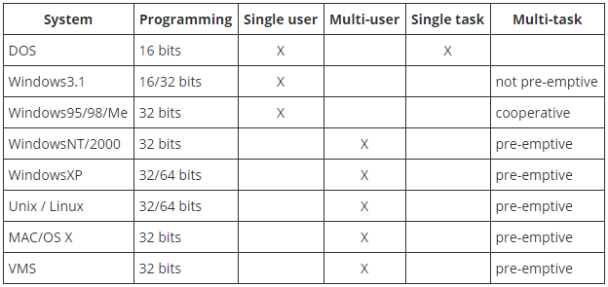

References:

<http://ccm.net/contents/664-operating-system>

# DATA COMMUNICATION AND COMPUTER NETWORK

## Computer Network Types

Generally, networks are distinguished based on their geographical span. A network can be as small as distance between your mobile phone and its Bluetooth headphone and as large as the internet itself, covering the whole geographical world.

**Personal Area Network**

A Personal Area Network (PAN) is smallest network which is very personal to a user. This may include Bluetooth enabled devices or infra-red enabled devices. PAN has connectivity range up to 10 meters. PAN may include wireless computer keyboard and mouse, Bluetooth enabled headphones, wireless printers and TV remotes.

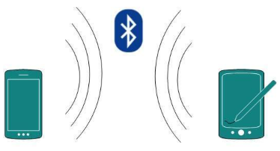

Personal Area Network (PAN)

For example, Piconet is Bluetooth-enabled Personal Area Network which may contain up to 8 devices connected together in a master-slave fashion.

**Local Area Network**

A computer network spanned inside a building and operated under single administrative system is generally termed as Local Area Network (LAN). Usually,LAN covers an organization’ offices, schools, colleges or universities. Number of systems connected in LAN may vary from as least as two to as much as 16 million.

LAN provides a useful way of sharing the resources between end users.The resources such as printers, file servers, scanners, and internet are easily sharable among computers.

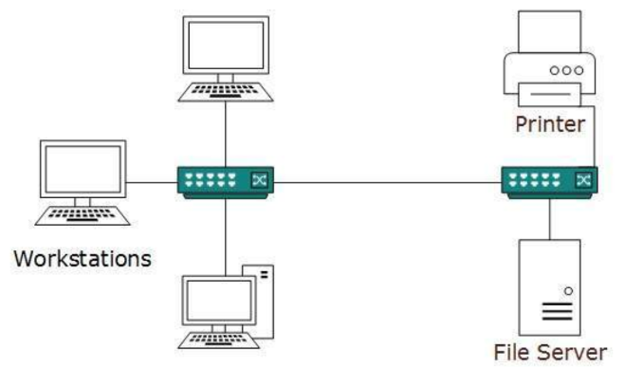

Local Area Network (LAN)

LANs are composed of inexpensive networking and routing equipment. It may contains local servers serving file storage and other locally shared applications. It mostly operates on private IP addresses and does not involve heavy routing. LAN works under its own local domain and controlled centrally.

LAN uses either Ethernet or Token-ring technology. Ethernet is most widely employed LAN technology and uses Star topology, while Token-ring is rarely seen.

LAN can be wired, wireless, or in both forms at once.

**Metropolitan Area Network**

The Metropolitan Area Network (MAN) generally expands throughout a city such as cable TV network. It can be in the form of Ethernet,Token-ring, ATM, or Fiber Distributed Data Interface (FDDI).

Metro Ethernet is a service which is provided by ISPs. This service enables its users to expand their Local Area Networks. For example, MAN can help an organization to connect all of its offices in a city.

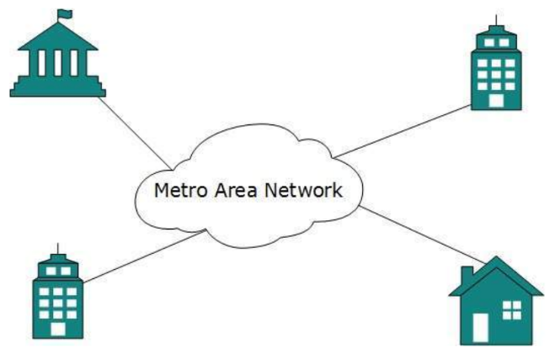

Metro Area Network (MAN)

Backbone of MAN is high-capacity and high-speed fiber optics. MAN works in between Local Area Network and Wide Area Network. MAN provides uplink for LANs to WANs or internet.

**Wide Area Network**

As the name suggests,the Wide Area Network (WAN) covers a wide area which may span across provinces and even a whole country. Generally, telecommunication networks are Wide Area Network. These networks provide connectivity to MANs and LANs. Since they are equipped with very high speed backbone, WANs use very expensive network equipment.

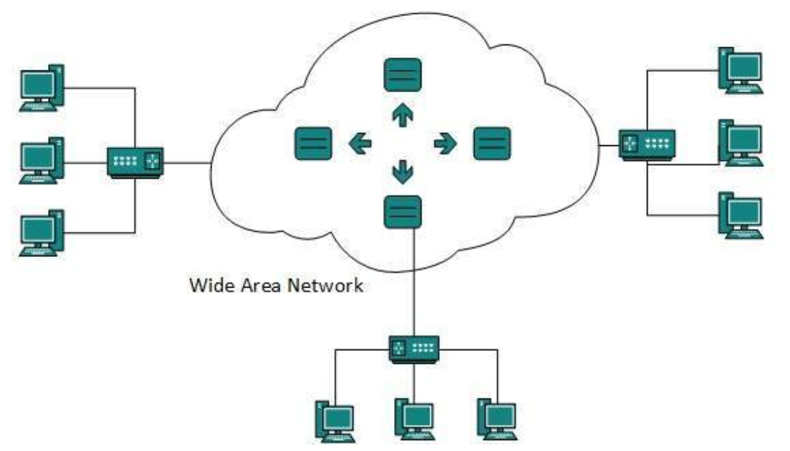

Wide Area Network (WAN)

WAN may use advanced technologies such as Asynchronous Transfer Mode (ATM), Frame Relay, and Synchronous Optical Network (SONET). WAN may be managed by multiple administration.

**Internetwork**

A network of networks is called an internetwork, or simply the internet. It is the largest network in existence on this planet.The internet hugely connects all WANs and it can have connection to LANs and Home networks. Internet uses TCP/IP protocol suite and uses IP as its addressing protocol. Present day, Internet is widely implemented using IPv4. Because of shortage of address spaces, it is gradually migrating from IPv4 to IPv6.

Internet enables its users to share and access enormous amount of information worldwide. It uses WWW, FTP, email services, audio and video streaming etc. At huge level, internet works on Client-Server model.

Internet uses very high speed backbone of fiber optics. To inter-connect various continents, fibers are laid under sea known to us as submarine communication cable.

Internet is widely deployed on World Wide Web services using HTML linked pages and is accessible by client software known as Web Browsers. When a user requests a page using some web browser located on some Web Server anywhere in the world, the Web Server responds with the proper HTML page. The communication delay is very low.

Internet is serving many proposes and is involved in many aspects of life. Some of them are:

* Web sites • Marketing
* E-mail • Networking
* Instant Messaging • Resource Sharing
* Blogging • Audio and Video Streaming
* Social Media

Let us go through various LAN technologies in brief:

**Ethernet**

Ethernet is a widely deployed LAN technology.This technology was invented by Bob Metcalfe and D.R. Boggs in the year 1970. It was standardized in IEEE 802.3 in 1980.

Ethernet shares media. Network which uses shared media has high probability of data collision. Ethernet uses Carrier Sense Multi Access/Collision Detection (CSMA/CD) technology to detect collisions. On the occurrence of collision in Ethernet, all its hosts roll back, wait for some random amount of time, and then re-transmit the data.

Ethernet connector is,network interface card equipped with 48-bits MAC address. This helps other Ethernet devices to identify and communicate with remote devices in Ethernet.

Traditional Ethernet uses 10BASE-T specifications.The number 10 depicts 10MBPS speed, BASE stands for baseband, and T stands for Thick Ethernet. 10BASE-T Ethernet provides transmission speed up to 10MBPS and uses coaxial cable or Cat-5 twisted pair cable with RJ-45 connector. Ethernet follows star topology with segment length up to 100 meters. All devices are connected to a hub/switch in a star fashion.

**Fast-Ethernet**

To encompass need of fast emerging software and hardware technologies, Ethernet extends itself as Fast-Ethernet. It can run on UTP, Optical Fiber, and wirelessly too. It can provide speed up to 100 MBPS. This standard is named as 100BASE-T in IEEE 803.2 using Cat-5 twisted pair cable. It uses CSMA/CD technique for wired media sharing among the Ethernet hosts and CSMA/CA (CA stands for Collision Avoidance) technique for wireless Ethernet LAN.

Fast Ethernet on fiber is defined under 100BASE-FX standard which provides speed up to 100 MBPS on fiber. Ethernet over fiber can be extended up to 100 meters in half-duplex mode and can reach maximum of 2000 meters in full-duplex over multimode fibers.

**Giga-Ethernet**

After being introduced in 1995, Fast-Ethernet could enjoy its high speed status only for 3 years till Giga-Ethernet introduced. Giga-Ethernet provides speed up to 1000 mbits/seconds. IEEE802.3ab standardize Giga-Ethernet over UTP using Cat-5, Cat-5e and Cat-6 cables. IEEE802.3ah defines Giga-Ethernet over Fiber.

## Computer Network Toplogies

A Network Topology is the arrangement with which computer systems or network devices are connected to each other. Topologies may define both physical and logical aspect of the network. Both logical and physical topologies could be same or different in a same network.

**Point-to-Point**

Point-to-point networks contains exactly two hosts such as computer, switches or routers, servers connected back to back using a single piece of cable. Often, the receiving end of one host is connected to sending end of the other and vice-versa.

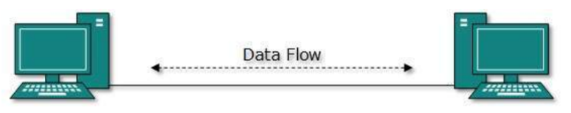

Point-to-Point

If the hosts are connected point-to-point logically, then may have multiple intermediate devices. But the end hosts are unaware of underlying network and see each other as if they are connected directly.

**Bus Topology**

In case of Bus topology, all devices share single communication line or cable.Bus topology may have problem while multiple hosts sending data at the same time. Therefore, Bus topology either uses CSMA/CD technology or recognizes one host as Bus Master to solve the issue. It is one of the simple forms of networking where a failure of a device does not affect the other devices. But failure of the shared communication line can make all other devices stop functioning.

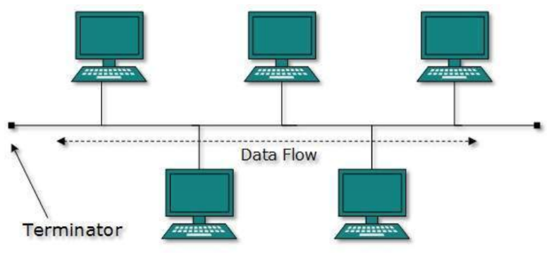

Bus Topology

Both ends of the shared channel have line terminator. The data is sent in only one direction and as soon as it reaches the extreme end, the terminator removes the data from the line.

**Star Topology**

All hosts in Star topology are connected to a central device, known as hub device, using a point-to-point connection. That is, there exists a point to point connection between hosts and hub. The hub device can be any of the following:

* Layer-1 device such as hub or repeater
* Layer-2 device such as switch or bridge
* Layer-3 device such as router or gateway

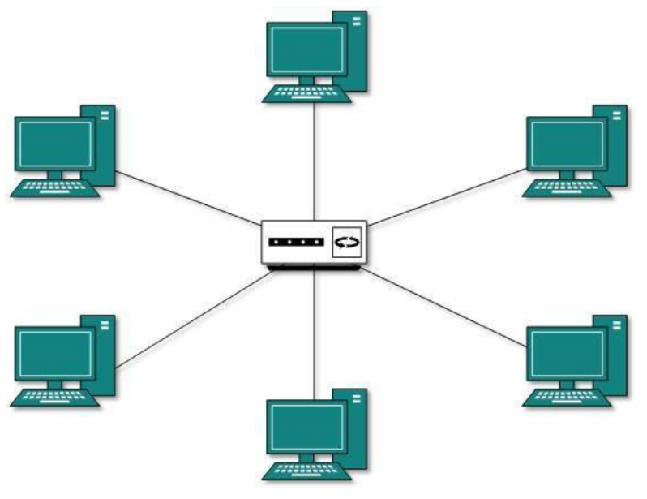

Star Topology

As in Bus topology, hub acts as single point of failure. If hub fails, connectivity of all hosts to all other hosts fails. Every communication between hosts, takes place through only the hub.Star topology is not expensive as to connect one more host, only one cable is required and configuration is simple.

**Ring Topology**

In ring topology, each host machine connects to exactly two other machines, creating a circular network structure. When one host tries to communicate or send message to a host which is not adjacent to it, the data travels through all intermediate hosts. To connect one more host in the existing structure, the administrator may need only one more extra cable.

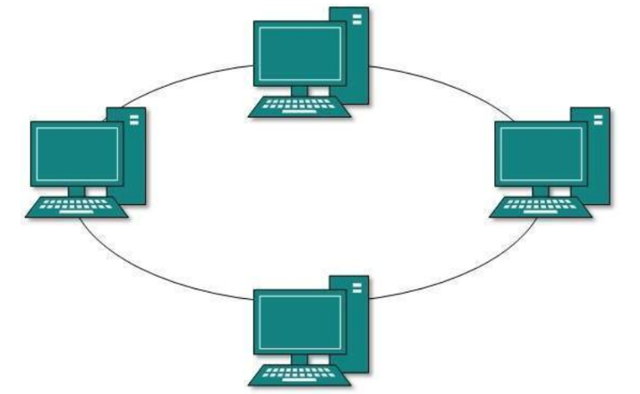

Ring Topology

Failure of any host results in failure of the whole ring.Thus, every connection in the ring is a point of failure. There are methods which employ one more backup ring.

**Hybrid Topology**

A network structure whose design contains more than one topology is said to be hybrid topology. Hybrid topology inherits merits and demerits of all the incorporating topologies.

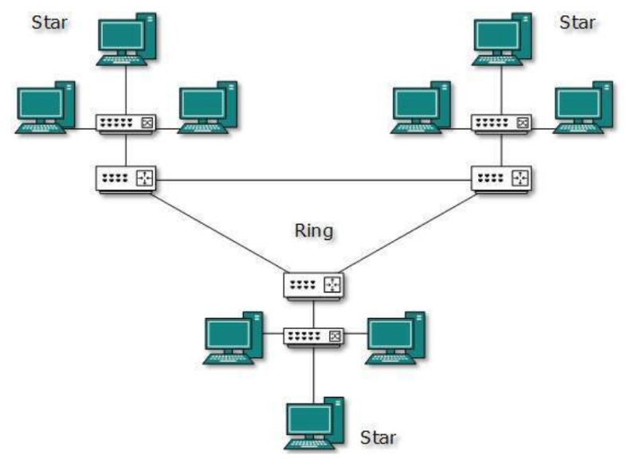

Hybrid Topology

The above picture represents an arbitrarily hybrid topology. The combining topologies may contain attributes of Star, Ring, Bus, and Daisy-chain topologies. Most WANs are connected by means of Dual-Ring topology and networks connected to them are mostly Star topology networks. **Internet** is the best example of **largest Hybrid topology**

## OSI Model

Open System Interconnect is an open standard for all communication systems. OSI model is established by International Standard Organization (ISO). This model has seven layers:

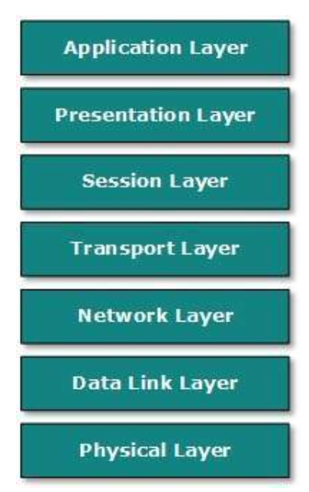

OSI Model

* **Application Layer**: This layer is responsible for providing interface to the application user. This layer encompasses protocols which directly interact with the user.
* **Presentation Layer**: This layer defines how data in the native format of remote host should be presented in the native format of host.
* **Session Layer**: This layer maintains sessions between remote hosts. For example, once user/password authentication is done, the remote host maintains this session for a while and does not ask for authentication again in that time span.
* **Transport Layer**: This layer is responsible for end-to-end delivery between hosts.
* **Network Layer**: This layer is responsible for address assignment and uniquely addressing hosts in a network.
* **Data Link Layer**: This layer is responsible for reading and writing data from and onto the line. Link errors are detected at this layer.
* **Physical Layer**: This layer defines the hardware, cabling wiring, power output, pulse rate etc.

## Internet Model

Internet uses TCP/IP protocol suite, also known as Internet suite. This defines Internet Model which contains four layered architecture. OSI Model is general communication model but Internet Model is what the internet uses for all its communication.The internet is independent of its underlying network architecture so is its Model. This model has the following layers:

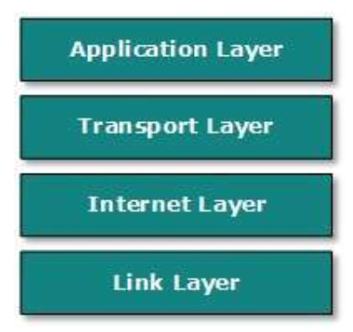

Internet Model

* **Application Layer**: This layer defines the protocol which enables user to interact with the network.For example, FTP, HTTP etc.
* **Transport Layer**: This layer defines how data should flow between hosts. Major protocol at this layer is Transmission Control Protocol (TCP). This layer ensures data delivered between hosts is in-order and is responsible for end-to-end delivery.
* **Internet Layer**: Internet Protocol (IP) works on this layer. This layer facilitates host addressing and recognition. This layer defines routing.
* **Link Layer**: This layer provides mechanism of sending and receiving actual data.Unlike its OSI Model counterpart, this layer is independent of underlying network architecture and hardware.

References:

https://www.tutorialspoint.com/data_communication_computer_network/, Data Communication and Computer Network, Tutorials Point (I) Pvt. Ltd., 2015.

# DATABASE MANAGEMENT – THE CONCEPT

## OVERVIEW

**Database** is a collection of related data and data is a collection of facts and figures that can be processed to produce information. Mostly data represents recordable facts. Data aids in producing information, which is based on facts. For example, if we have data about marks obtained by all students, we can then conclude about toppers and average marks.

**A database management system** stores data in such a way that it becomes easier to retrieve, manipulate, and produce information.

**Characteristics**

Traditionally, data was organized in file formats. DBMS was a new concept then, and all the research was done to make it overcome the deficiencies in traditional style of data management. A modern DBMS has the following characteristics:

* **Real-world entity**: A modern DBMS is more realistic and uses real-world entities to design its architecture. It uses the behavior and attributes too. For example, a school database may use students as an entity and their age as an attribute.
* **Relation-based tables**: DBMS allows entities and relations among them to form tables. A user can understand the architecture of a database just by looking at the table names.
* **Isolation of data and application**: A database system is entirely different than its data. A database is an active entity, whereas data is said to be passive, on which the database works and organizes. DBMS also stores metadata, which is data about data, to ease its own process.
* **Less redundancy**: DBMS follows the rules of normalization, which splits a relation when any of its attributes is having redundancy in values. Normalization is a mathematically rich and scientific process that reduces data redundancy.
* **Consistency**: Consistency is a state where every relation in a database remains consistent. There exist methods and techniques, which can detect attempt of leaving database in inconsistent state. A DBMS can provide greater consistency as compared to earlier forms of data storing applications like file-processing systems.
* **Query Language**: DBMS is equipped with query language, which makes it more efficient to retrieve and manipulate data. A user can apply as many and as different filtering options as required to retrieve a set of data. Traditionally it was not possible where file-processing system was used.
* **ACID Properties**: DBMS follows the concepts of **A**tomicity, **C**onsistency, **I**solation, and **D**urability (normally shortened as ACID). These concepts are applied on transactions, which manipulate data in a database. ACID properties help the database stay healthy in multi-transactional environments and in case of failure.
* **Multiuser and Concurrent Access**: DBMS supports multi-user environment and allows them to access and manipulate data in parallel. Though there are restrictions on transactions when users attempt to handle the same data item, but users are always unaware of them.
* **Multiple views**: DBMS offers multiple views for different users. A user who is in the Sales department will have a different view of database than a person working in the Production department. This feature enables the users to have a concentrate view of the database according to their requirements.
* **Security**: Features like multiple views offer security to some extent where users are unable to access data of other users and departments. DBMS offers methods to impose constraints while entering data into the database and retrieving the same at a later stage. DBMS offers many different levels of security features, which enables multiple users to have different views with different features. For example, a user in the Sales department cannot see the data that belongs to the Purchase department.

Additionally, it can also be managed how much data of the Sales department should be displayed to the user. Since a DBMS is not saved on the disk as traditional file systems, it is very hard for miscreants to break the code.

**Users**

A typical DBMS has users with different rights and permissions who use it for different purposes. Some users retrieve data and some back it up. The users of a DBMS can be broadly categorized as follows:

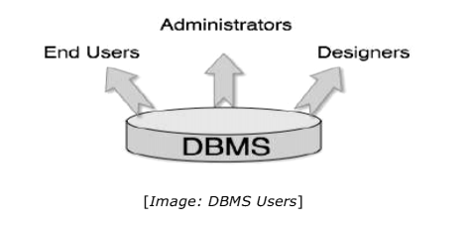

**Administrators**: Administrators maintain the DBMS and are responsible for administrating the database. They are responsible to look after its usage and by whom it should be used. They create access profiles for users and apply limitations to maintain isolation and force security.

Administrators also look after DBMS resources like system license, required tools, and other software and hardware related maintenance.

**Designers**: Designers are the group of people who actually work on the designing part of the database. They keep a close watch on what data should be kept and in what format. They identify and design the whole set of entities, relations, constraints, and views.

**End Users**: End users are those who actually reap the benefits of having a DBMS. End users can range from simple viewers who pay attention to the logs or market rates to sophisticated users such as business analysts.

## ARCHITECTURE

The design of a DBMS depends on its architecture. It can be centralized or decentralized or hierarchical. The architecture of a DBMS can be seen as either single tier or multi-tier. An n-tier architecture divides the whole system into related but independent n modules, which can be independently modified, altered, changed, or replaced.

In 1-tier architecture, the DBMS is the only entity where the user directly sits on the DBMS and uses it. Any changes done here will directly be done on the DBMS itself. It does not provide handy tools for end-users. Database designers and programmers normally prefer to use single-tier architecture.

If the architecture of DBMS is 2-tier, then it must have an application through which the DBMS can be accessed. Programmers use 2-tier architecture where they access the DBMS by means of an application. Here the application tier is entirely independent of the database in terms of operation, design, and programming.

**3-tier Architecture**

A 3-tier architecture separates its tiers from each other based on the complexity of the users and how they use the data present in the database. It is the most widely used architecture to design a DBMS.

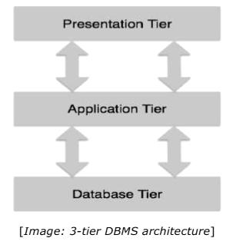

* **Database (Data) Tier**: At this tier, the database resides along with its query processing languages. We also have the relations that define the data and their constraints at this level.
* **Application (Middle) Tier**: At this tier reside the application server and the programs that access the database. For a user, this application tier presents an abstracted view of the database. End-users are unaware of any existence of the database beyond the application. At the other end, the database tier is not aware of any other user beyond the application tier. Hence, the application layer sits in the middle and acts as a mediator between the end-user and the database.
* **User (Presentation) Tier**: End-users operate on this tier and they know nothing about any existence of the database beyond this layer. At this layer, multiple views of the database can be provided by the application. All views are generated by applications that reside in the application tier.

Multiple-tier database architecture is highly modifiable, as almost all its components are independent and can be changed independently.

## DATA MODELS

Data models define how the logical structure of a database is modeled. Data Models are fundamental entities to introduce abstraction in a DBMS. Data models define how data is connected to each other and how they are processed and stored inside the system.

The very first data model could be flat data-models, where all the data used are to be kept in the same plane. Earlier data models were not so scientific, hence they were prone to introduce lots of duplication and update anomalies.

**Entity-Relationship Model**

Entity-Relationship (ER) Model is based on the notion of real-world entities and relationships among them. While formulating real-world scenario into the database model, the ER Model creates entity set, relationship set, general attributes, and constraints.

ER Model is best used for the conceptual design of a database.

ER Model is based on:

* Entities and their attributes.
* Relationships among entities.

These concepts are explained below.

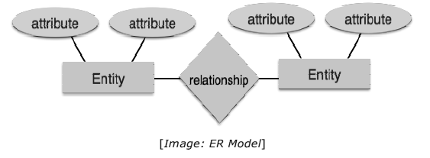

* **Entity**

An entity in an ER Model is a real-world entity having properties called attributes. Every attribute is defined by its set of values called domain.

For example, in a school database, a student is considered as an entity. Student has various attributes like name, age, class, etc.

* **Relationship**

The logical association among entities is called relationship.

Relationships are mapped with entities in various ways. Mapping cardinalities define the number of association between two entities.

* **Mapping Cardinalites**

Cardinality defines the number of entities in one entity set, which can be associated with the number of entities of other set via relationship set.

* **One-to-one**: One entity from entity set A can be associated with at most one entity of entity set B and vice versa.

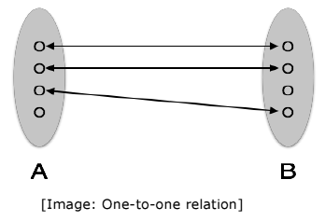

* **One-to-many**: One entity from entity set A can be associated with more than one entities of entity set B, however an entity from entity set B can be associated with at most one entity.

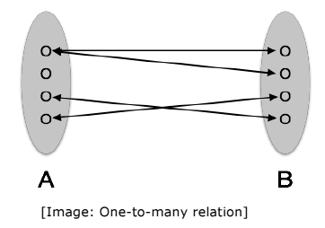

* **Many-to-one**: More than one entities from entity set A can be associated with at most one entity of entity set B, however an entity from entity set B can be associated with more than one entity from entity set A.

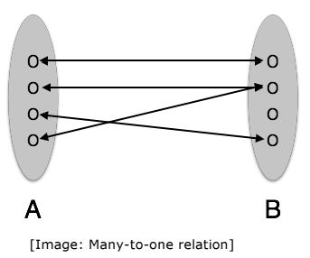

* **Many-to-many**: One entity from A can be associated with more than one entity from B and vice versa.

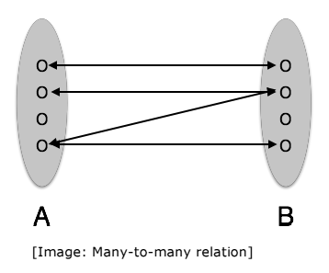

References:

<https://www.tutorialspoint.com/dbms/>, Database Management System, Tutorials Point (I) Pvt. Ltd., 2015.